**Yarmouk University**

**Hijjawi Faculty for Engineering Technology**

**Department of Computer Engineering**

Razan Wael Al-hazaimeh 2018980049 Computer engineering

Supervisor name: Dr. Mwaffaq Otoom

|  |
| --- |
|  |

In the beginning, I learned the basics of xamarin using c# language, then started with tasks:

**Xamarin task 1: build an app captures a photo using the mobile camera, display it inside the app and save it in the storage**

“Xamarin is an open-source platform for building modern and performant applications for iOS, Android, and Windows with .NET. Xamarin is an abstraction layer that manages communication of shared code with underlying platform code. Xamarin runs in a managed environment that provides conveniences such as memory allocation and garbage collection.

Xamarin enables developers to share an average of 90% of their application across platforms. This pattern allows developers to write all of their business logic in a single language (or reuse existing application code) but achieve native performance, look, and feel on each platform.

Xamarin applications can be written on PC or Mac and compile into native application packages, such as an. apk file on Android, or an. ipa file on iOS.”[1]

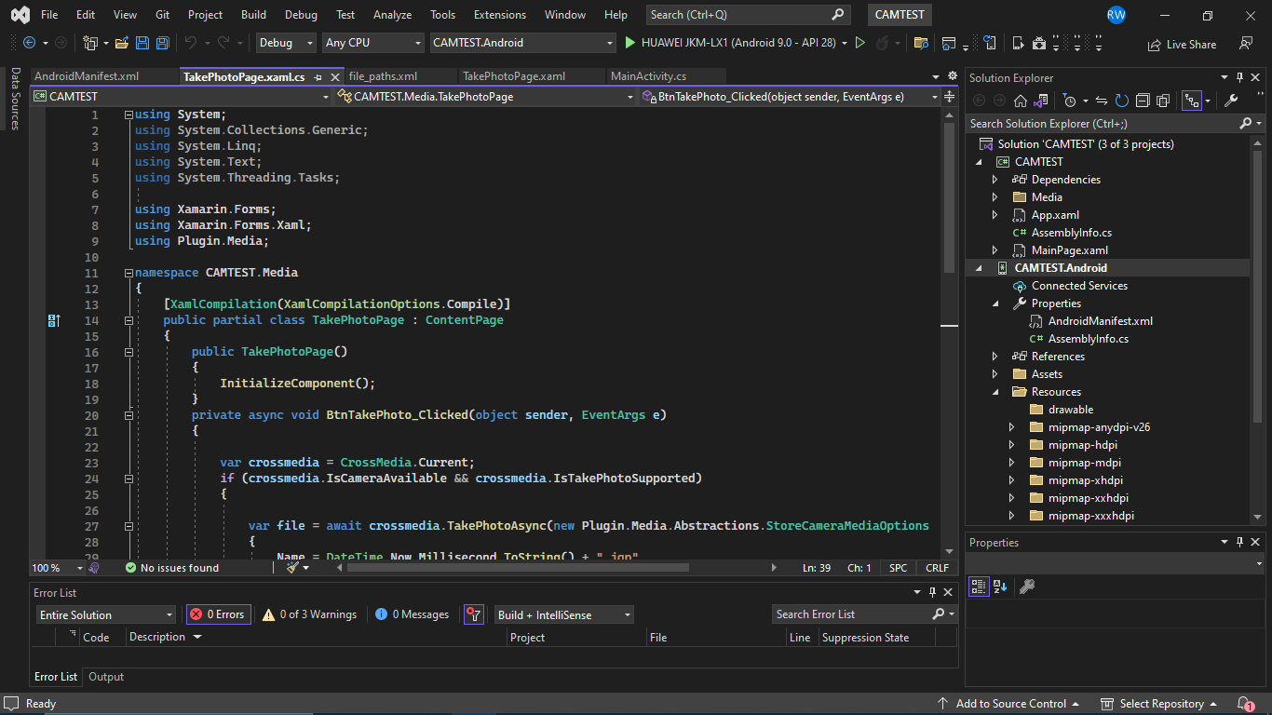

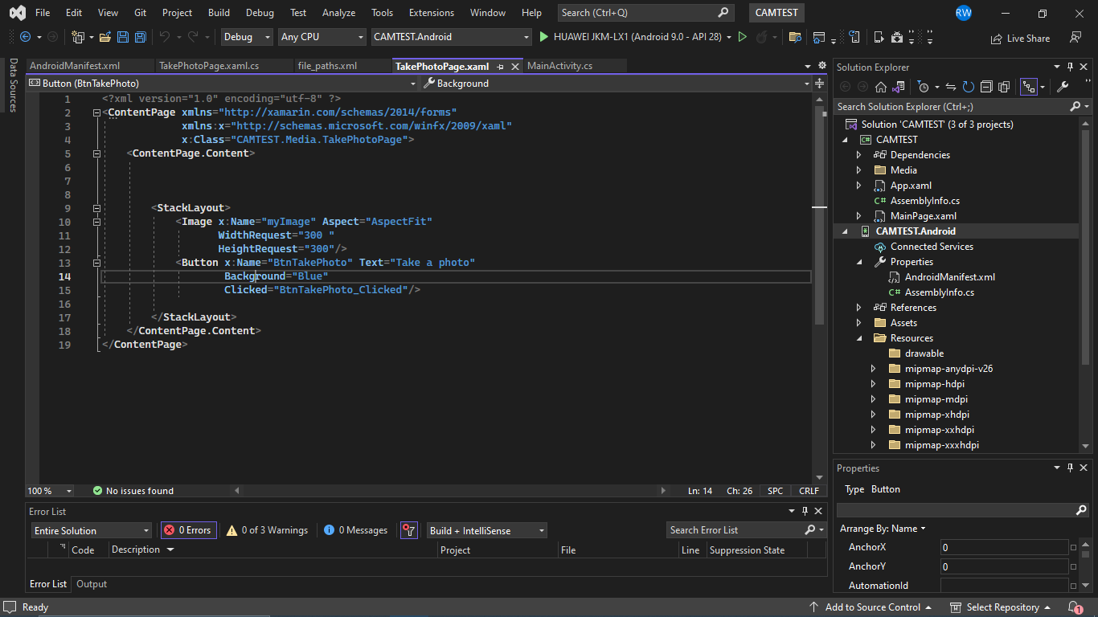

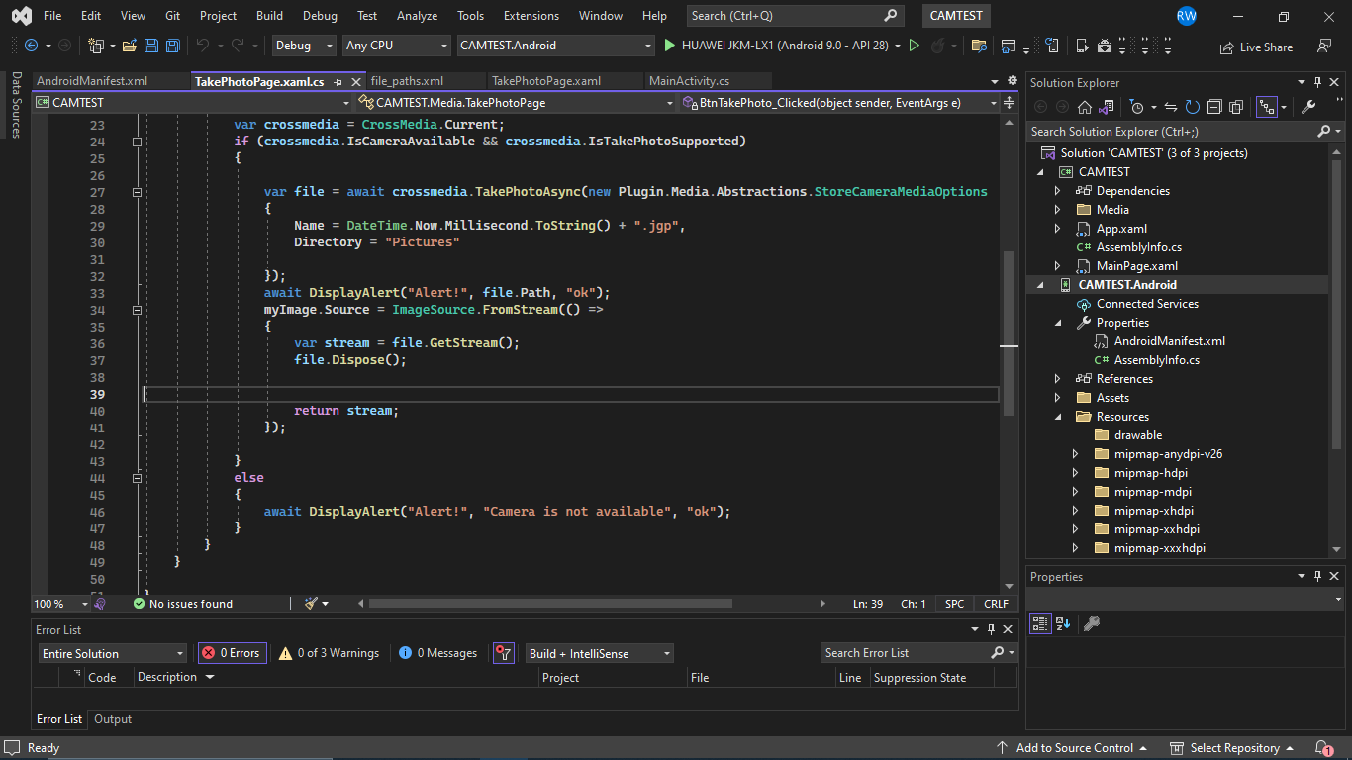

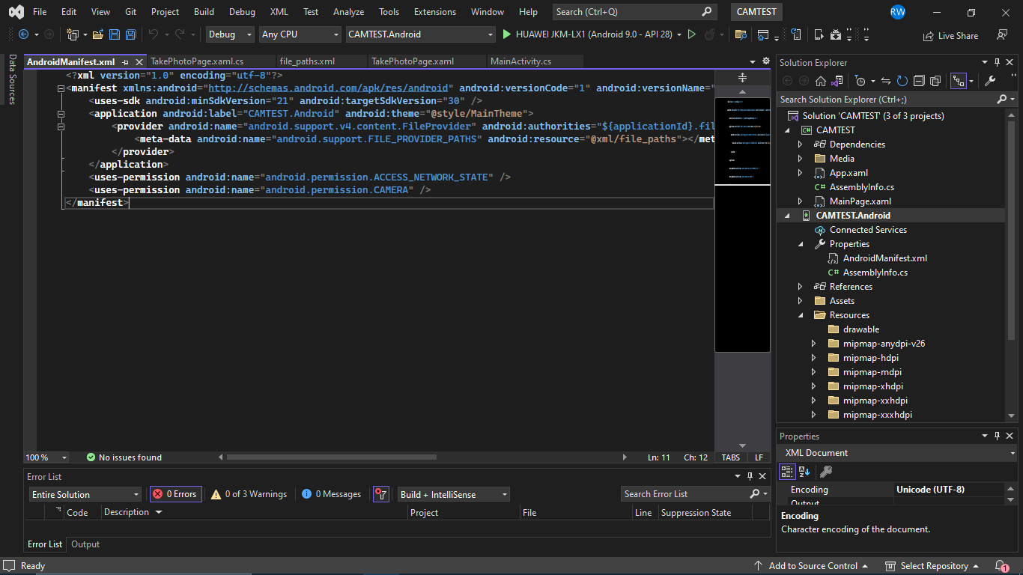

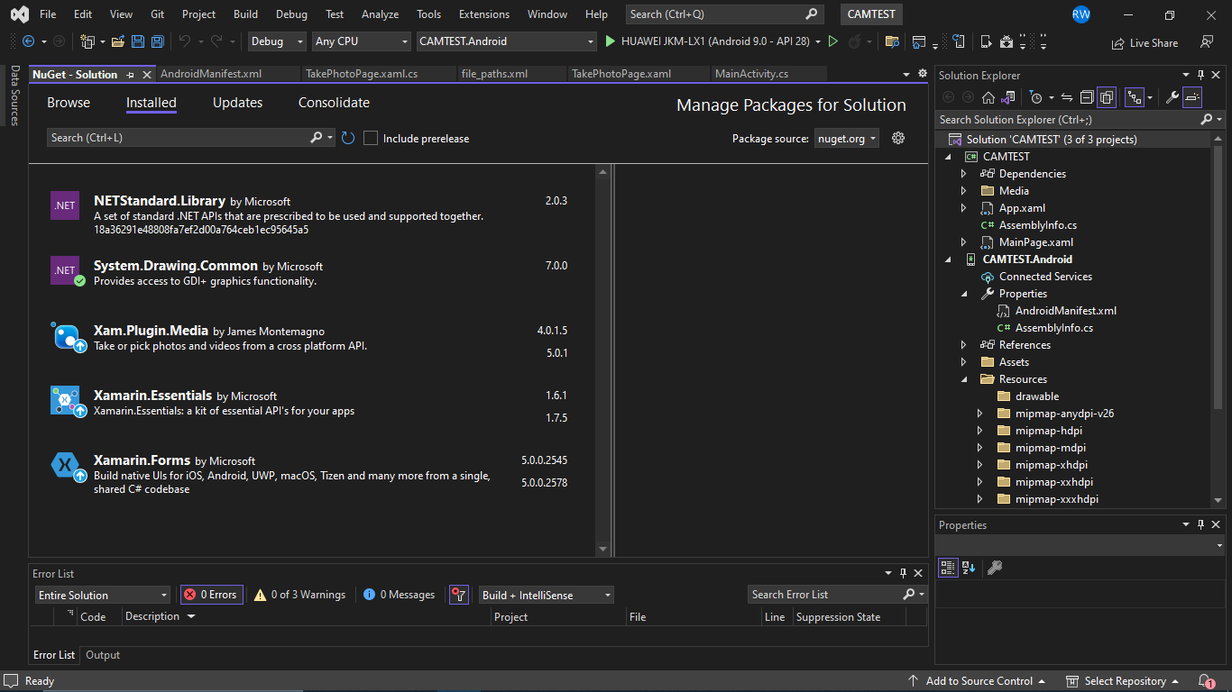

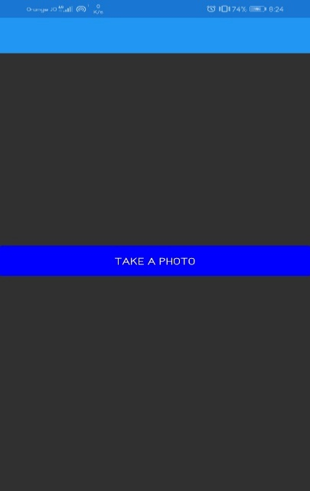

Some tutorials I used:

<https://www.c-sharpcorner.com/article/creating-a-camera-app-in-xamarin-android-app-using-visual-studio-2015/#:~:text=Creating%20A%20Camera%20App%20In%20Xamarin%20Android%20App,7%20...%208%20Step%208%20...%20More%20items>

<https://www.bing.com/videos/search?q=camera+app+using+xamarin&&view=detail&mid=FA669F94AF357BB22668FA669F94AF357BB22668&&FORM=VRDGAR&ru=%2Fvideos%2Fsearch%3Fq%3Dcamera%2Bapp%2Busing%2Bxamarin%26FORM%3DHDRSC6>

<https://www.bing.com/videos/search?q=camera+app+using+xamarin&&view=detail&mid=768E897D23D22DADB4B4768E897D23D22DADB4B4&&FORM=VRDGAR&ru=%2Fvideos%2Fsearch%3Fq%3Dcamera%2Bapp%2Busing%2Bxamarin%26FORM%3DHDRSC6>

<https://youtu.be/XTFkgpU44ZA>

**Xamarin task 2: add to your last app text extraction button, show the extracted text under the photo**

**If there's no text in the image, display an alert shows " no text"**

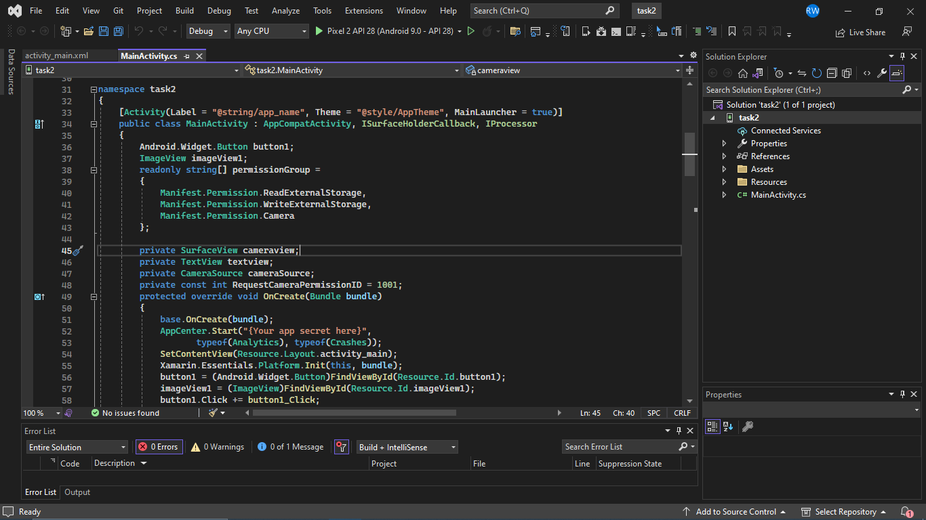

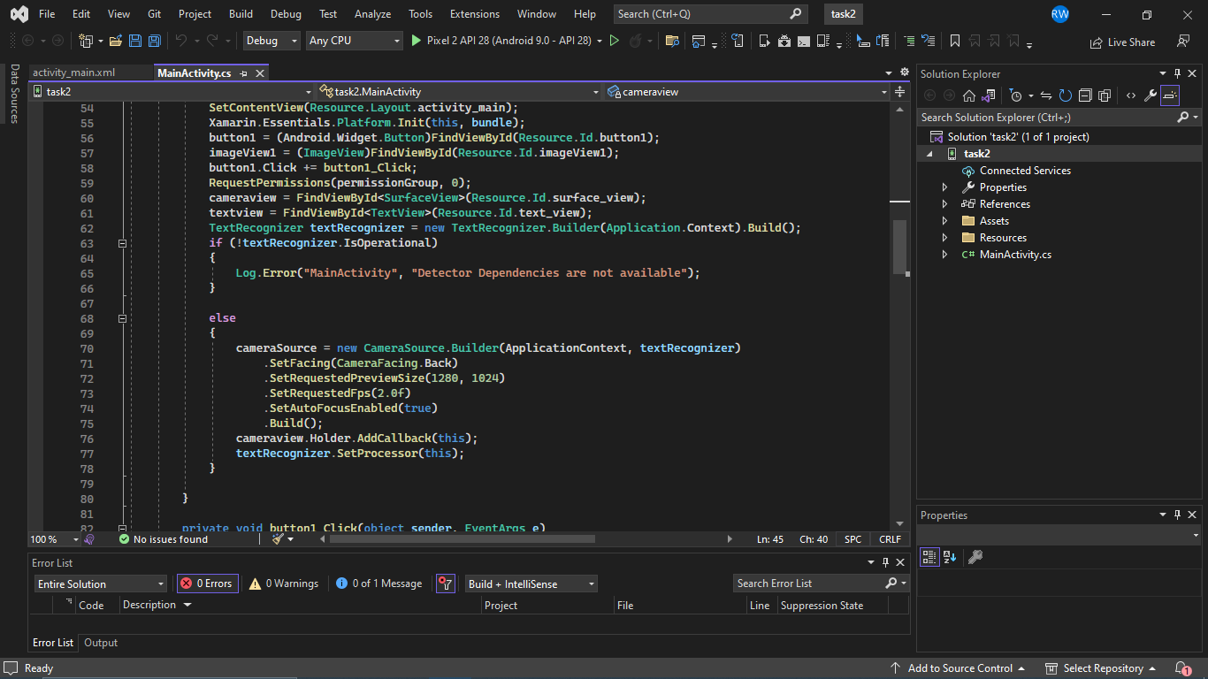

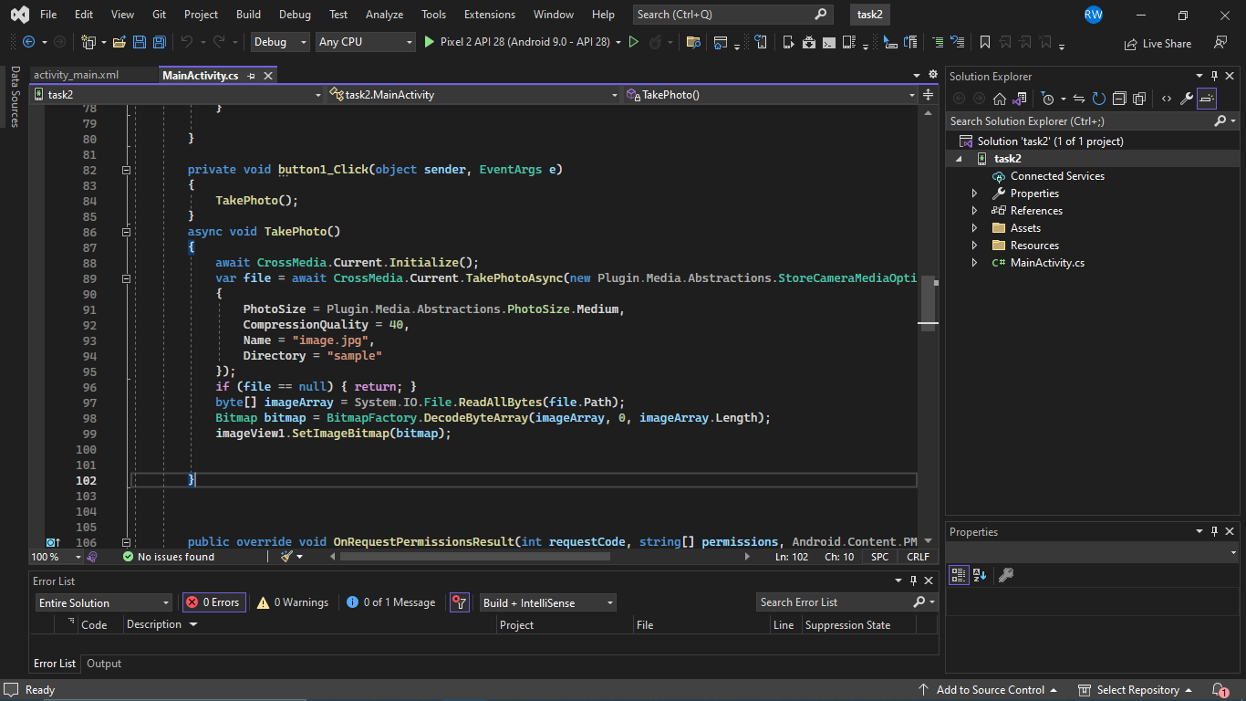

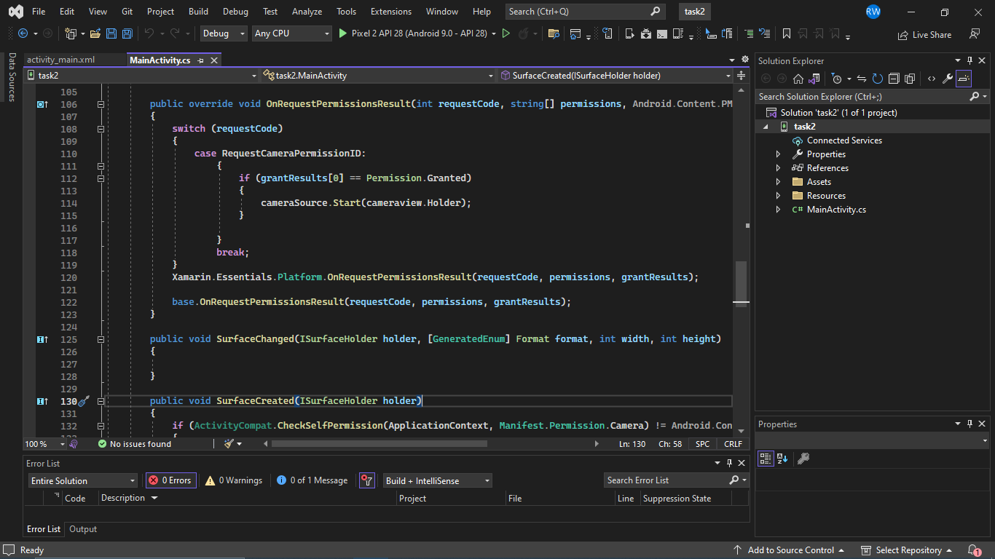

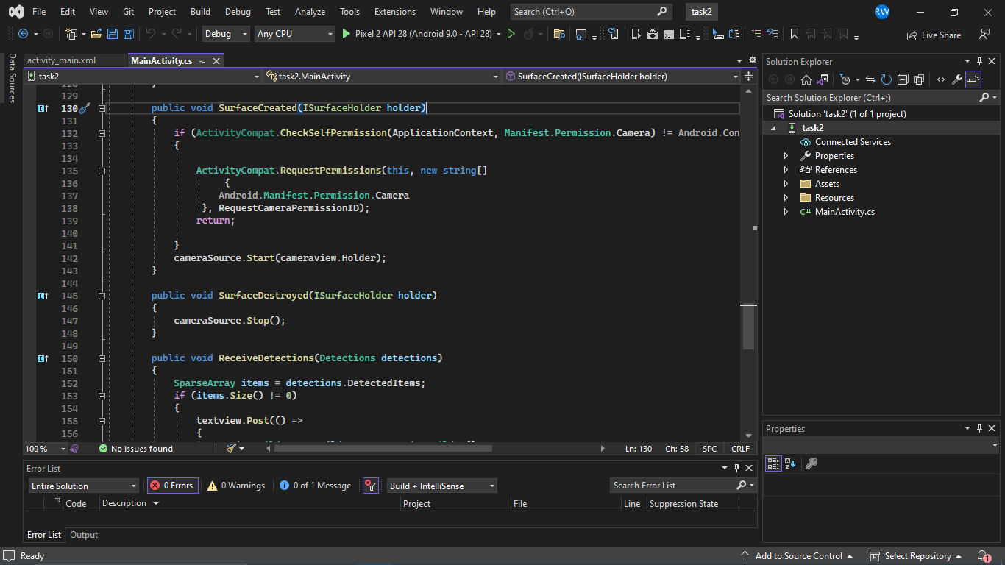

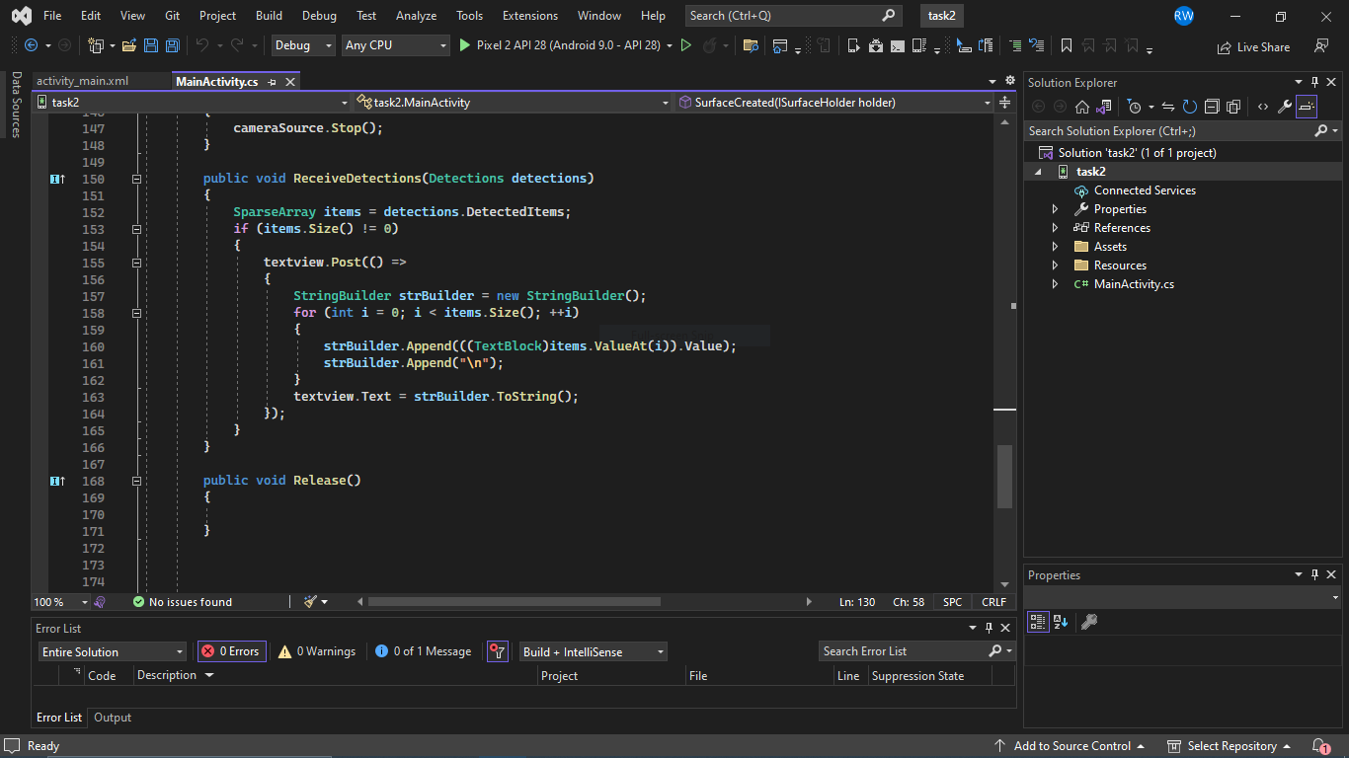

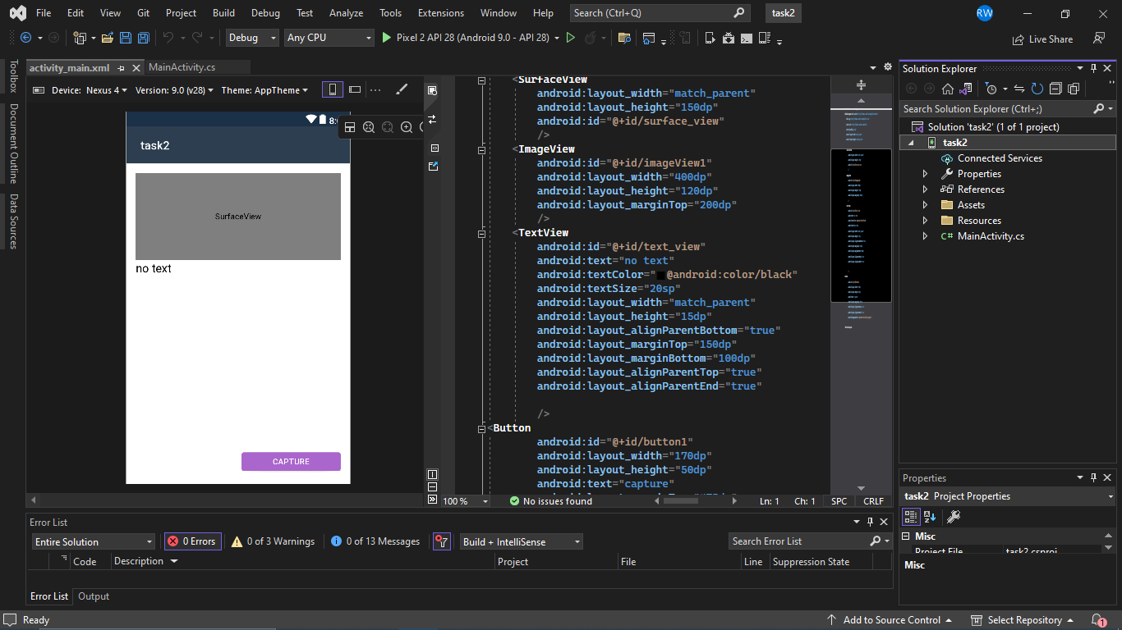

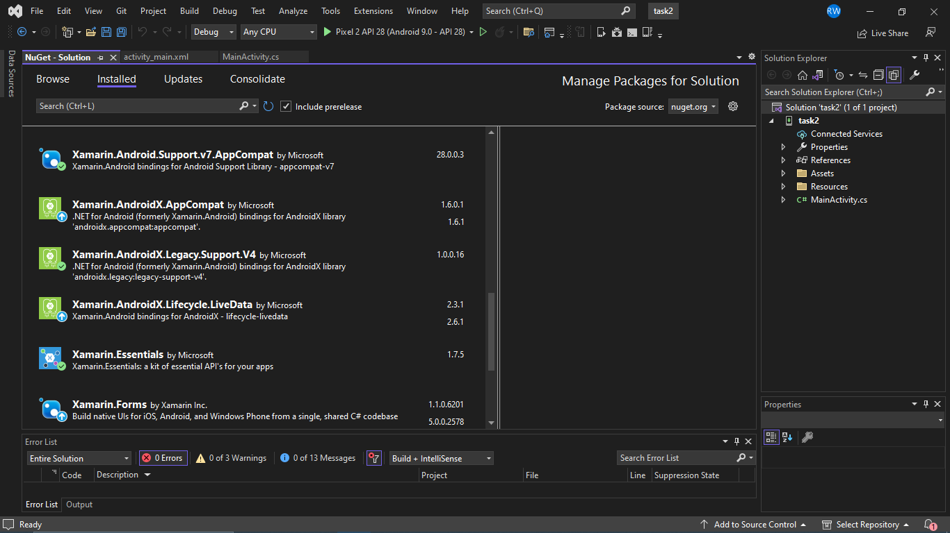

<https://www.bing.com/videos/search?q=text+recognition+xamarin+app&&view=detail&mid=B2E503307627DE828651B2E503307627DE828651&&FORM=VRDGAR&ru=%2Fvideos%2Fsearch%3Fq%3Dtext%2Brecognition%2Bxamarin%2Bapp%26FORM%3DHDRSC6>

<https://www.youtube.com/watch?v=3aRlYjSQPc8&ab_channel=EDMTDev>

<https://www.c-sharpcorner.com/article/xamarin-android-text-recognition-by-mobile-camera/>

**xamarin task 3:**

**According to the previous task, add a new page that connect your app to Azure,**

**and send the captured image to the cloud, confirm the process with an alert telling the user that the process is done**

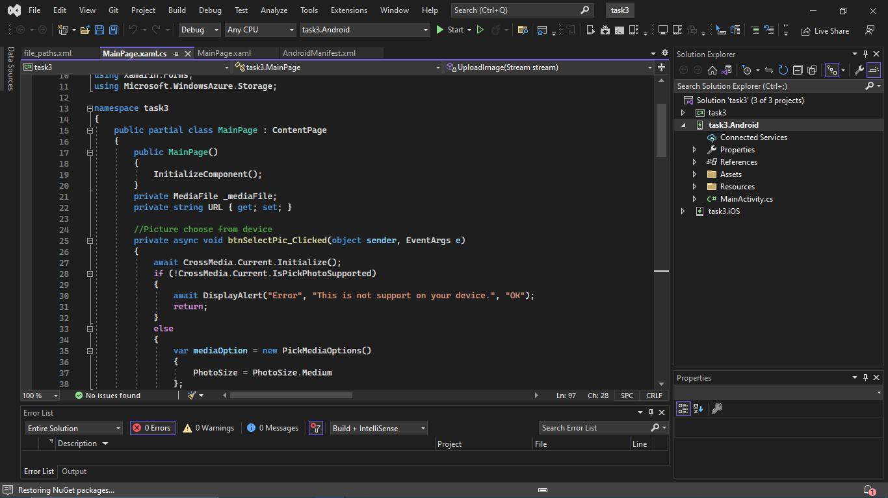

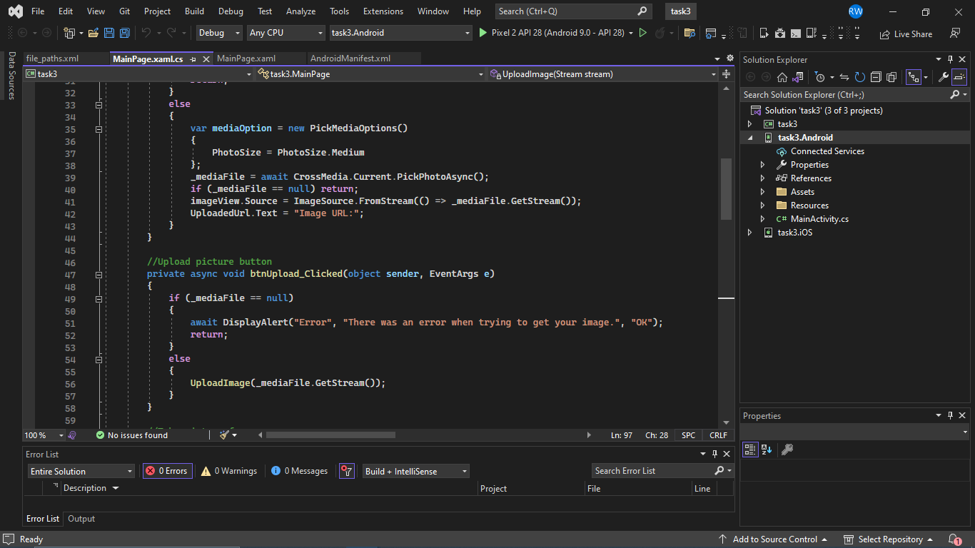

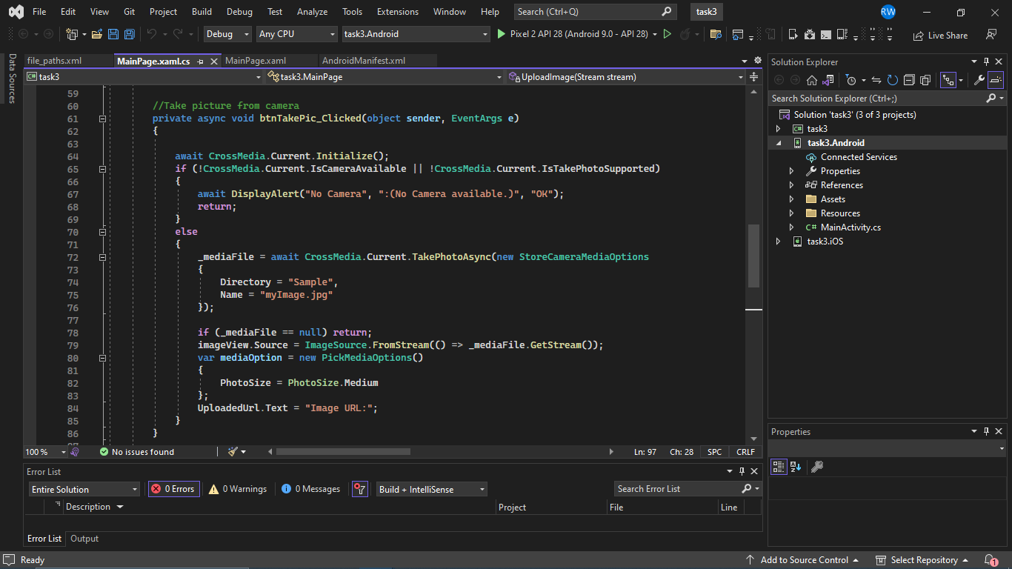

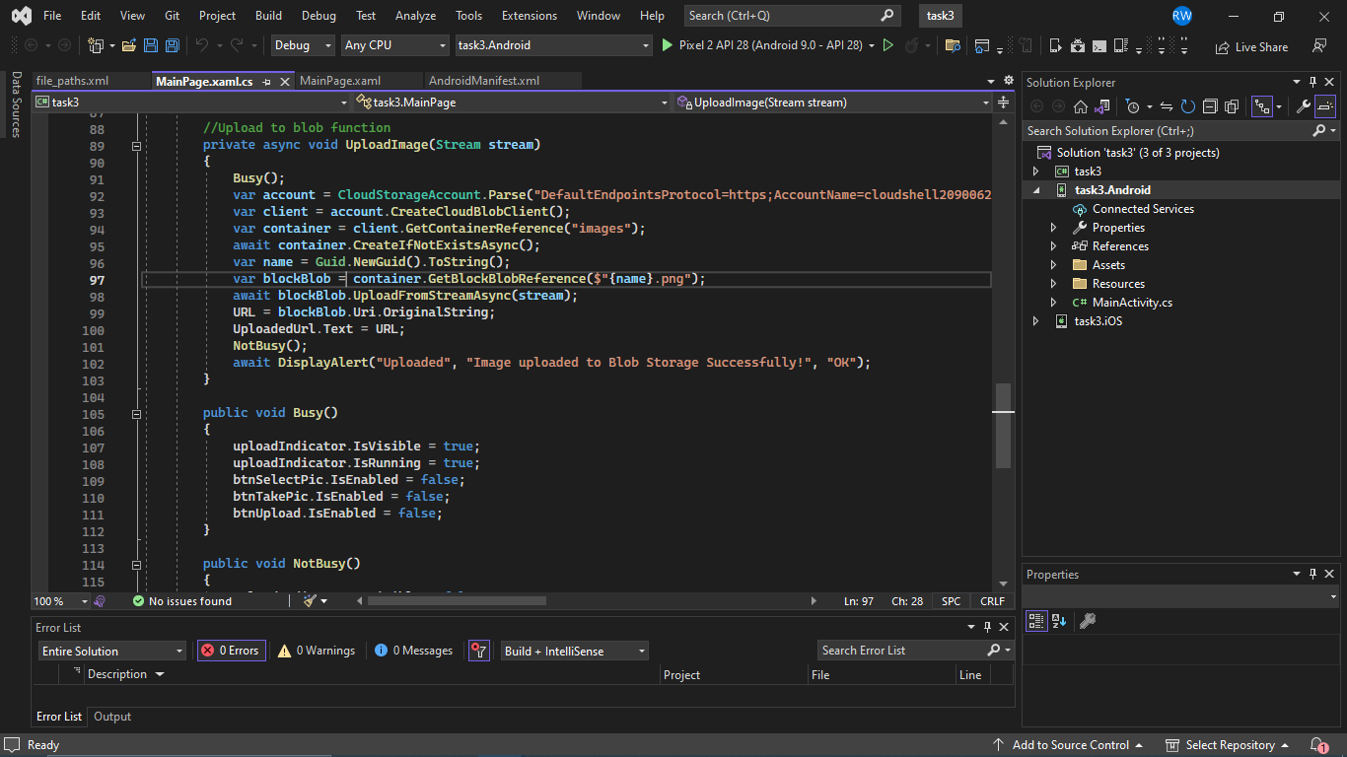

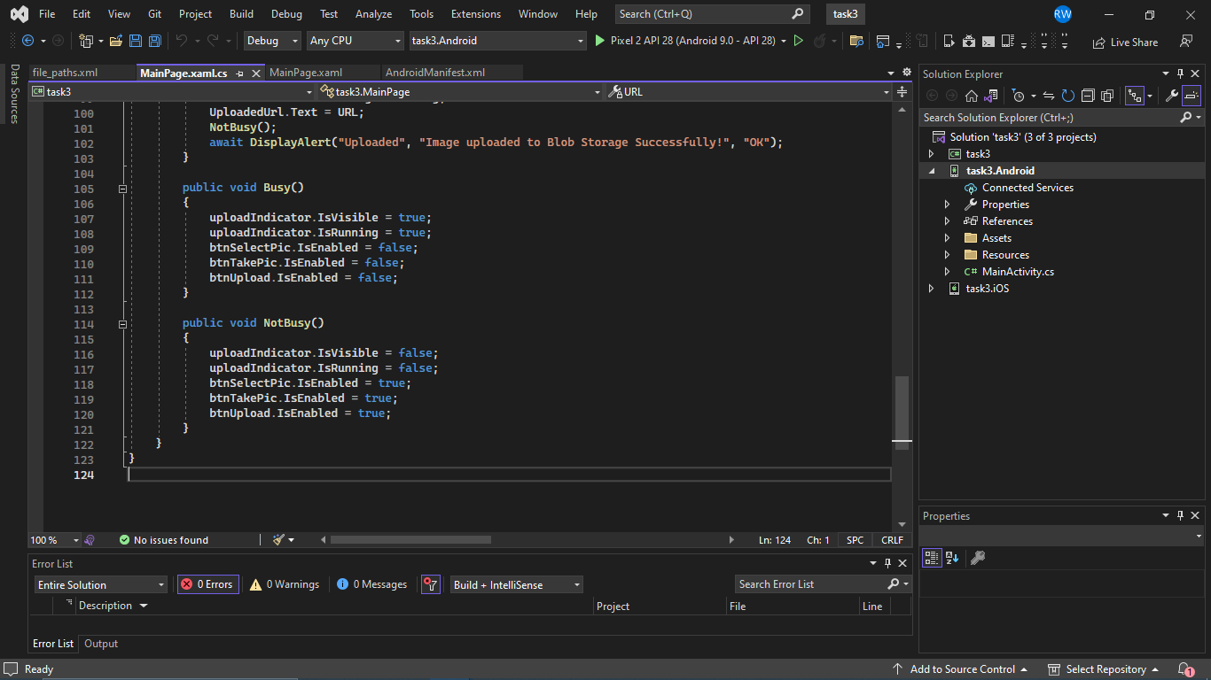

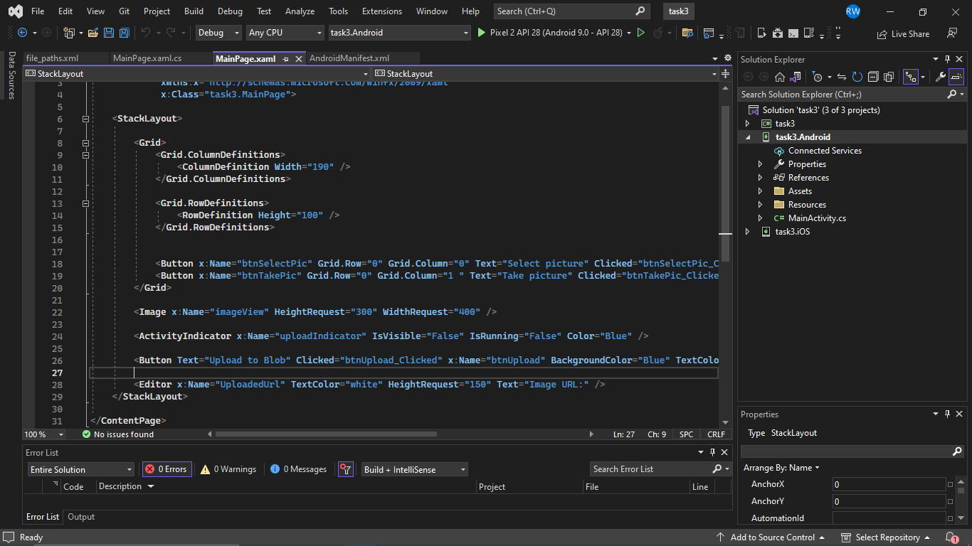

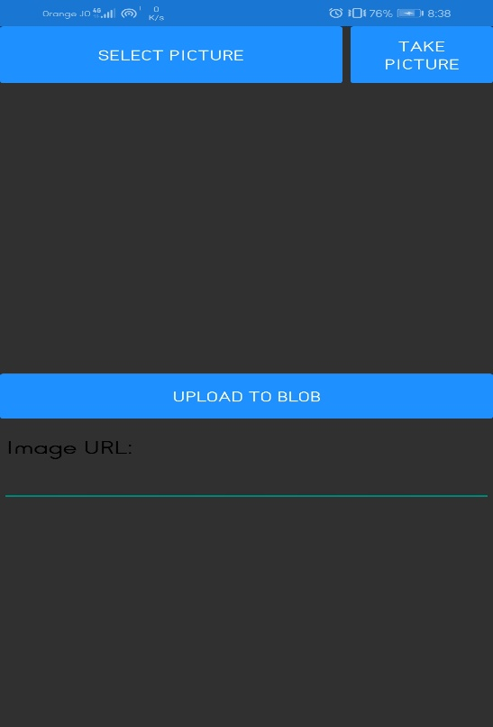

<https://learn.microsoft.com/en-us/azure/container-instances/container-instances-quickstart-portal>

<https://www.c-sharpcorner.com/article/xamarin-forms-upload-image-to-blob-storage/>

**Xamarin task 4:**

**Add zoom in zoom out feature to an image**

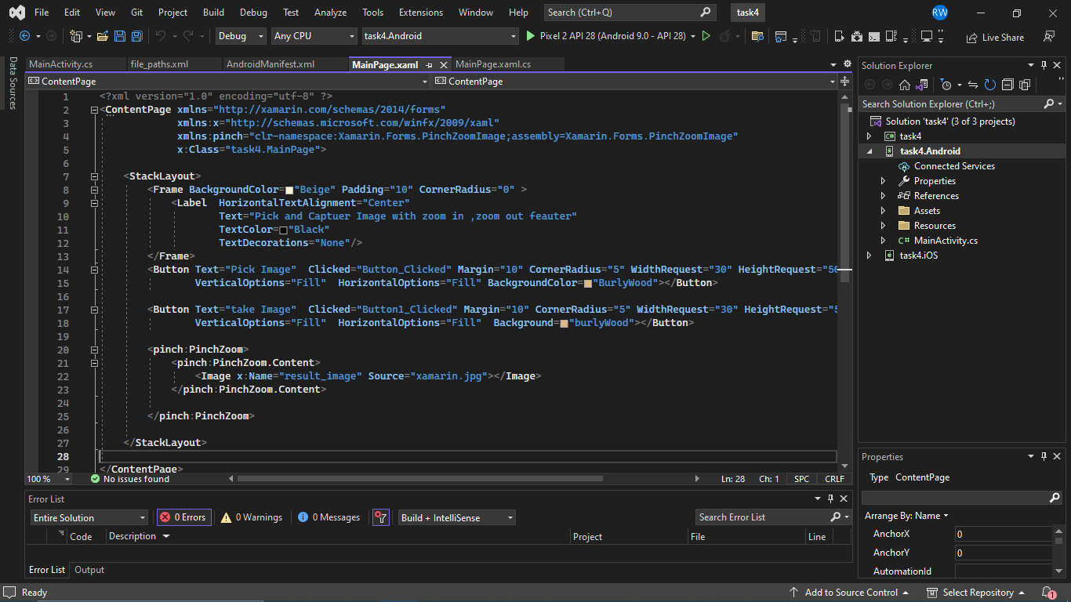

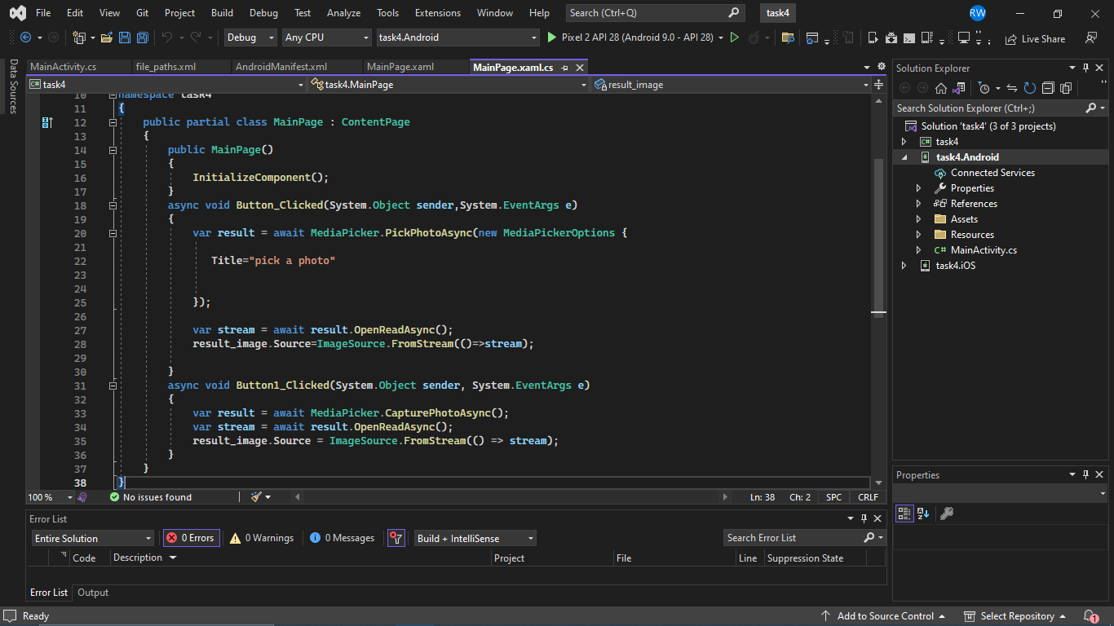

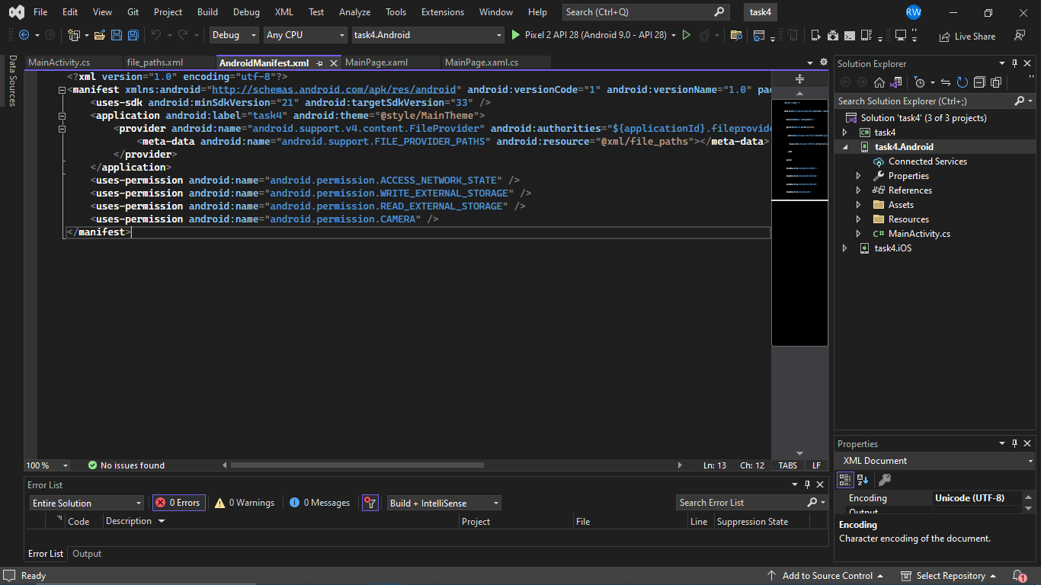



<https://www.c-sharpcorner.com/article/zoom-in/>

<https://www.youtube.com/watch?v=_IEmth2CWqY>

**Xamarin task 5: add some drawing to the image and save it**

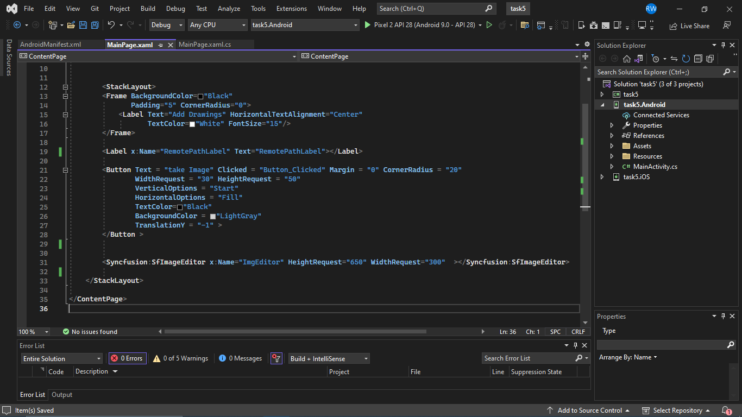

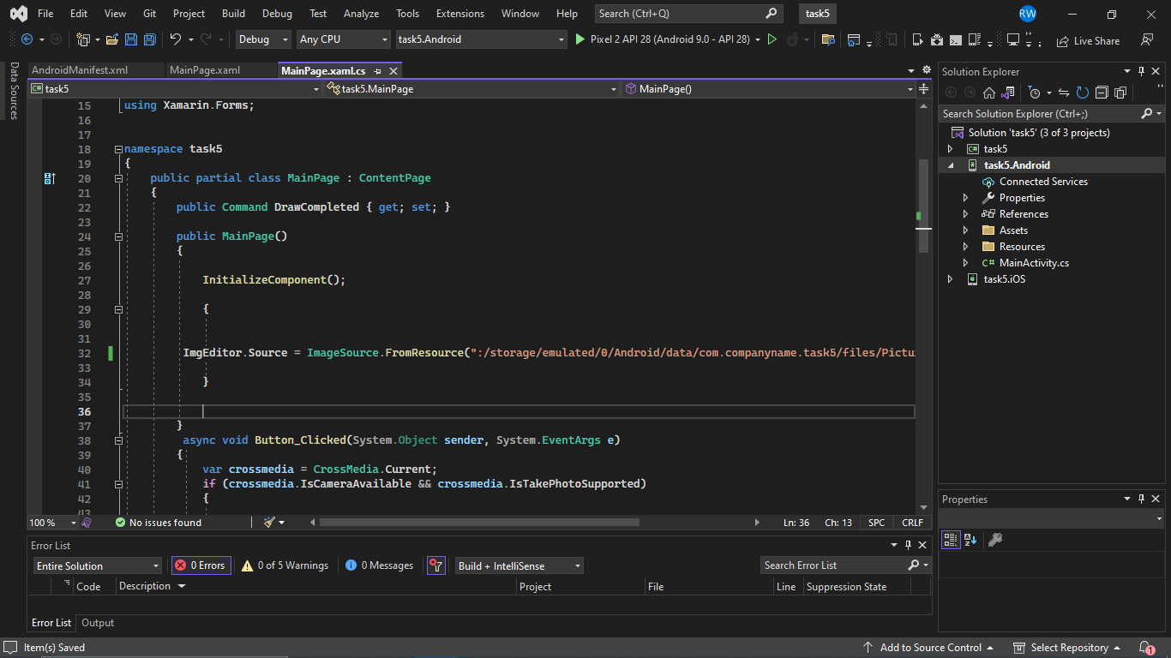

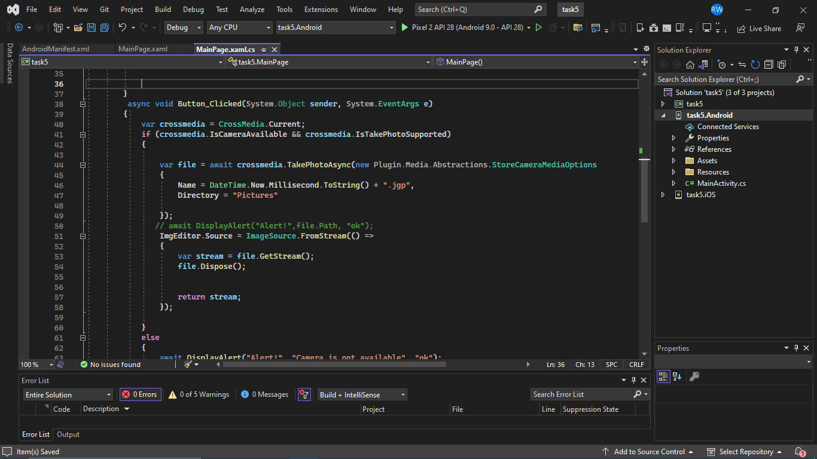

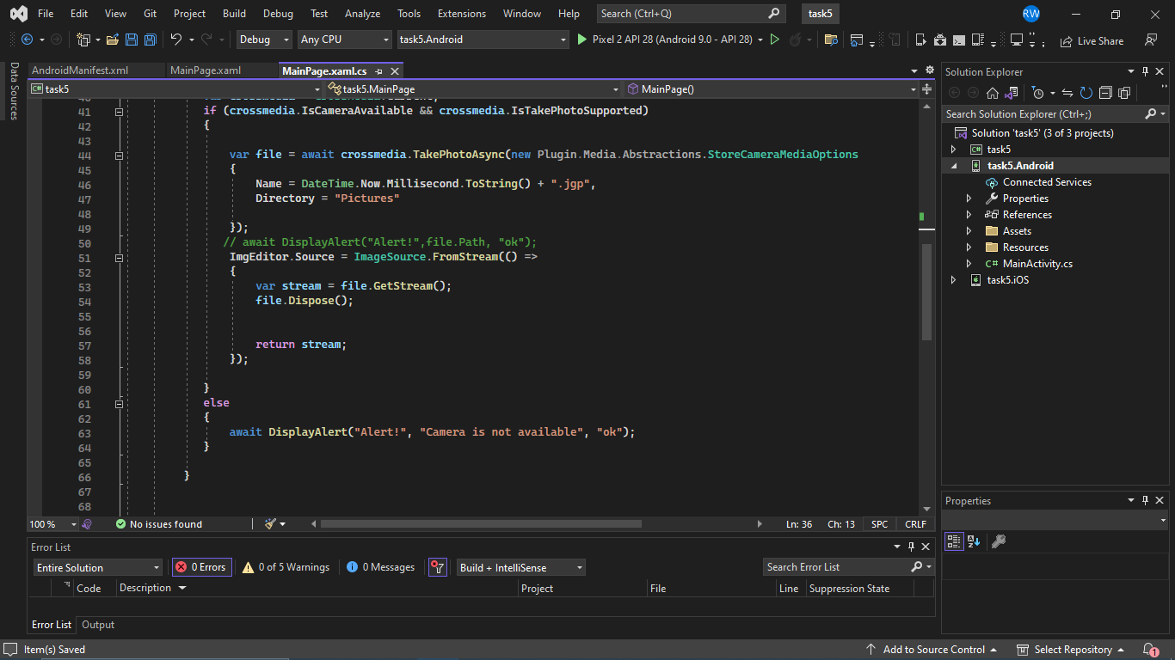

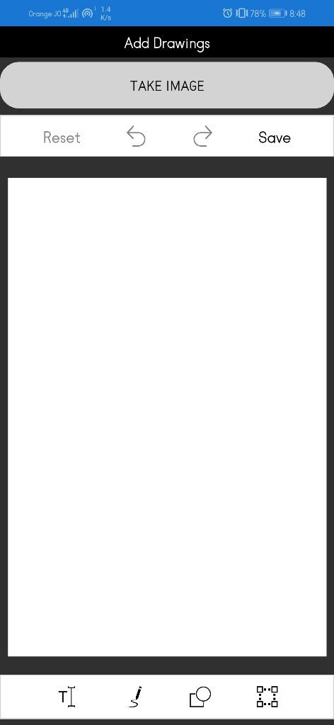

<https://youtu.be/SW1fsk7YbeA>

**Xamarin task 6: send a captured image to a local server using web API ,you need to make your pc as a server**

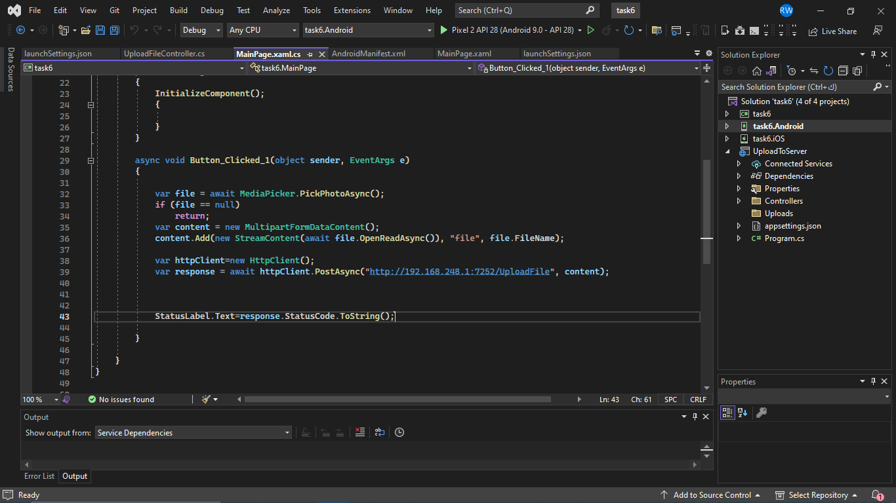

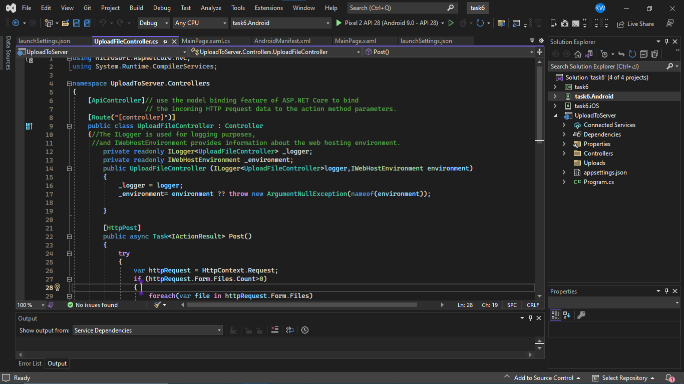

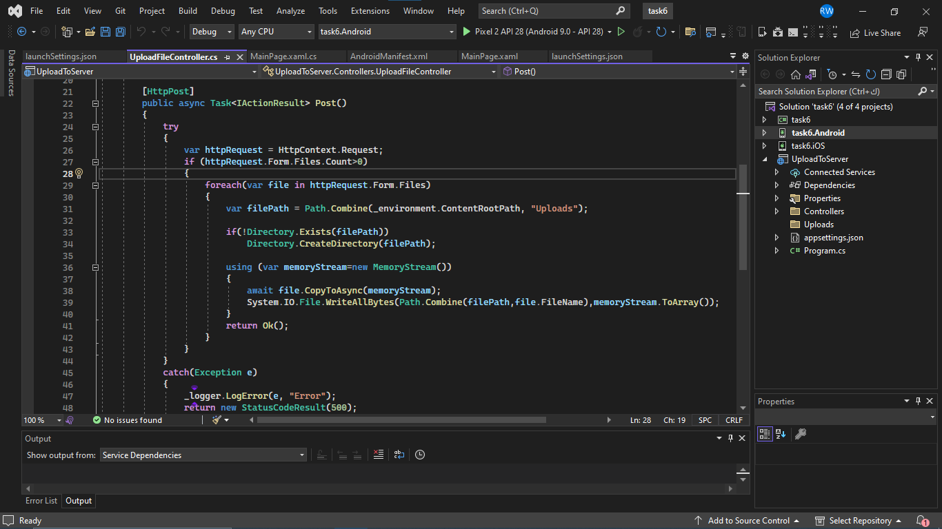

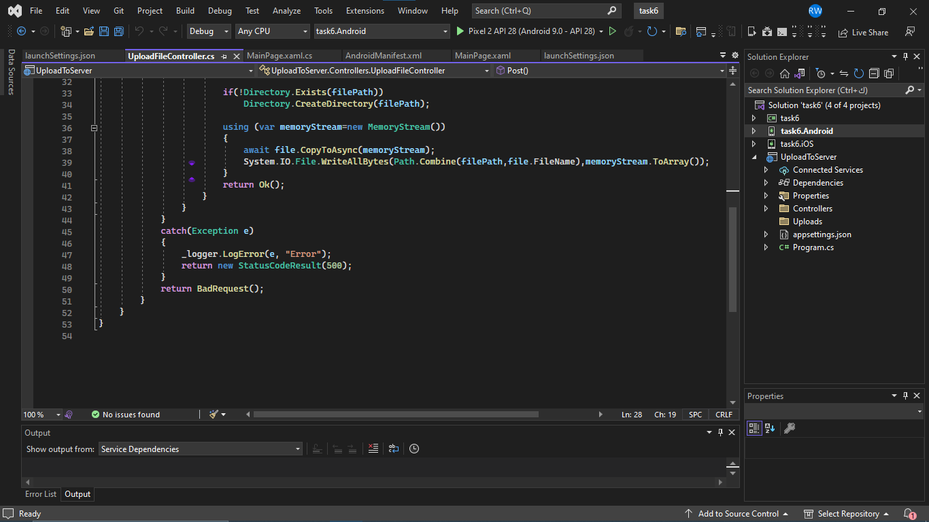

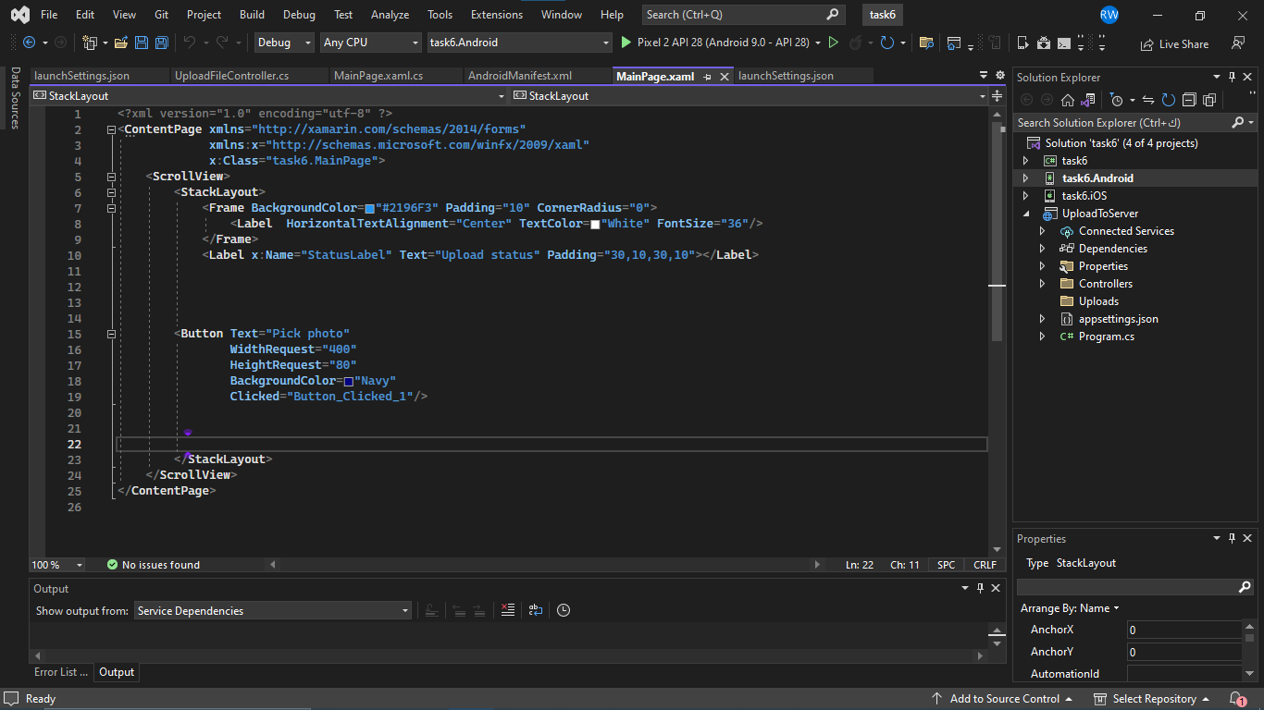

**Xamarin task7: deploy the yolo model (best.pt) on a camera captured image.**

**“Machine learning** is a subfield of artificial intelligence that focuses on the development of algorithms and statistical models that enable computers to learn and make predictions or decisions without being explicitly programmed. It involves training algorithms on large datasets to identify patterns and relationships. and then using these patterns to make predictions or decisions about new data.” [2]

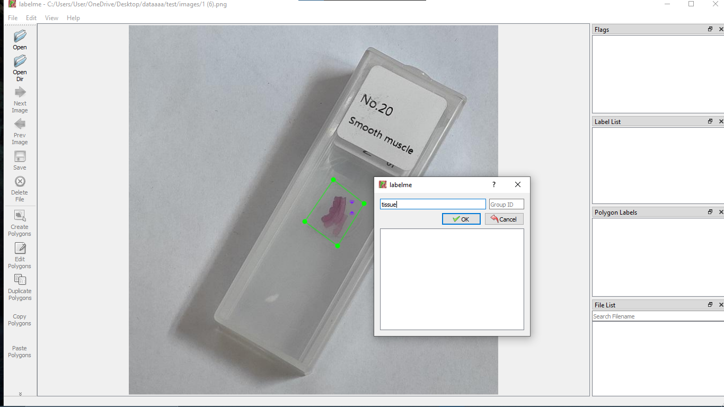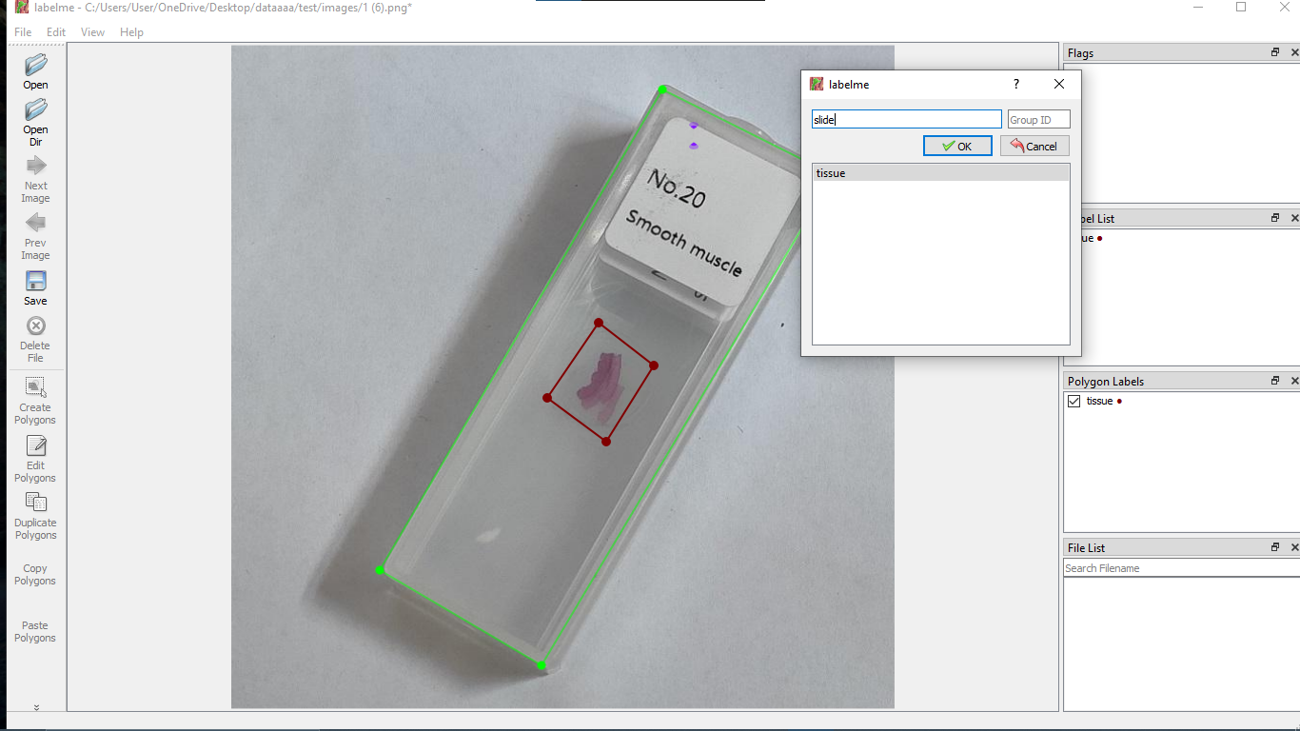

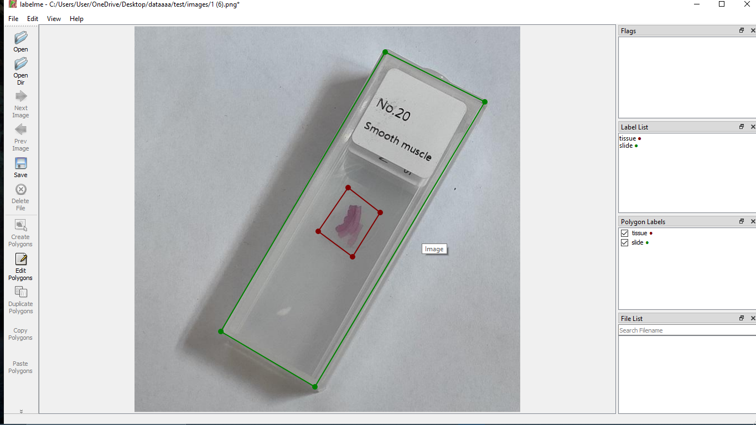

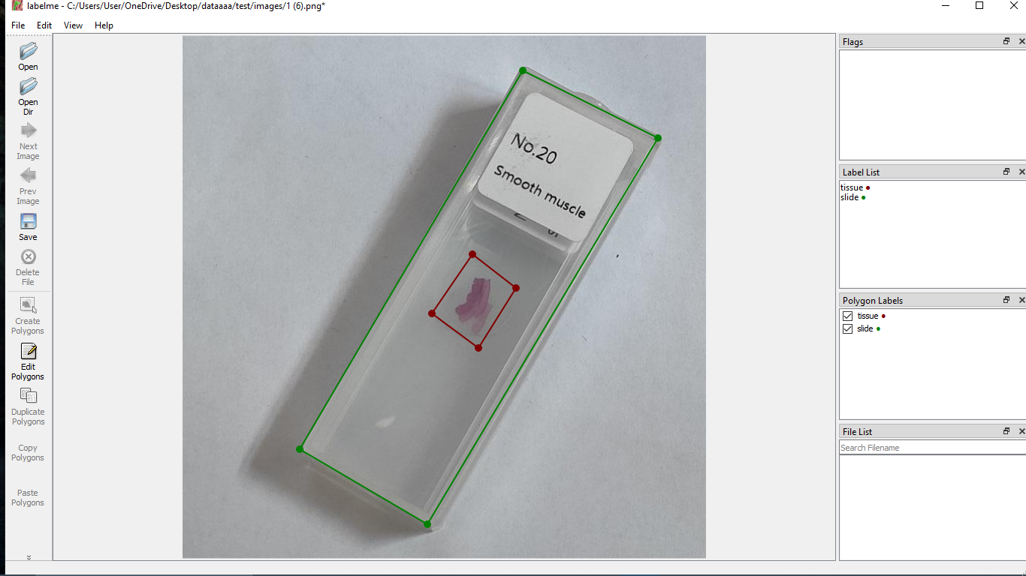

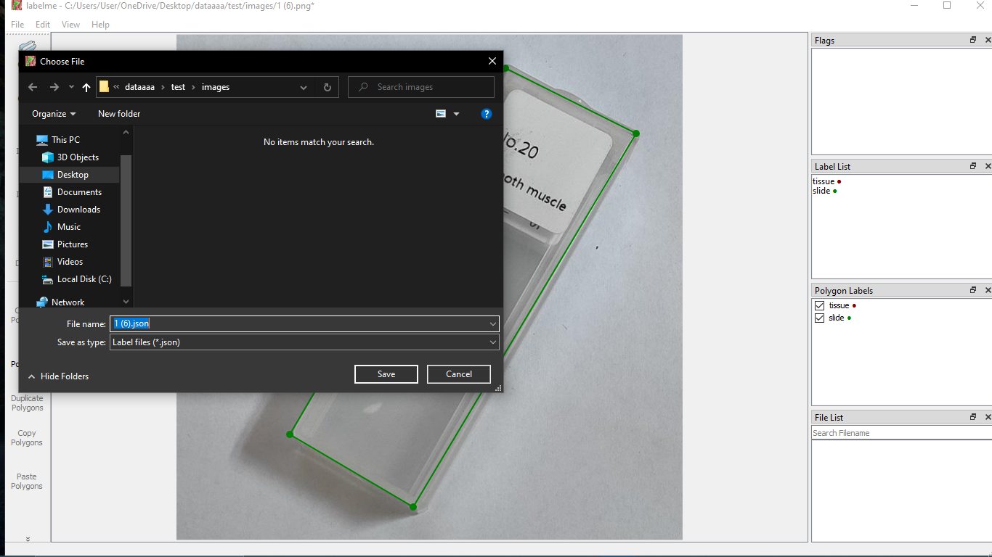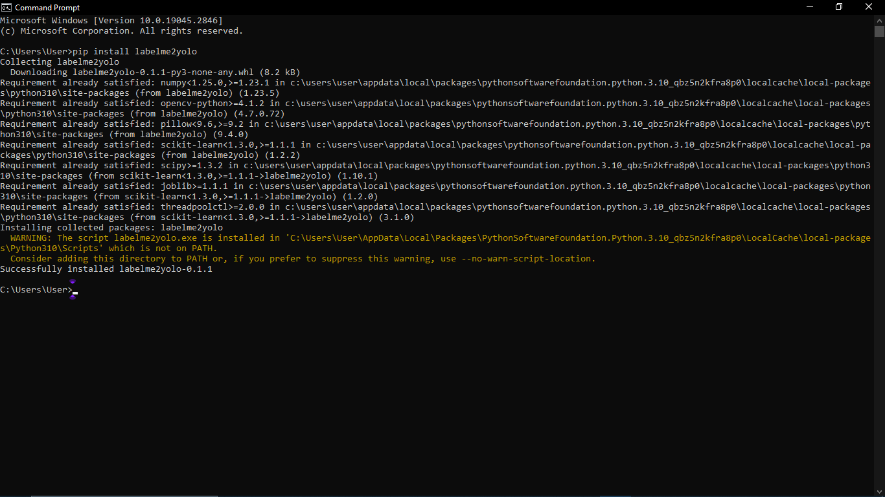

(Pip install labelme2yolo)

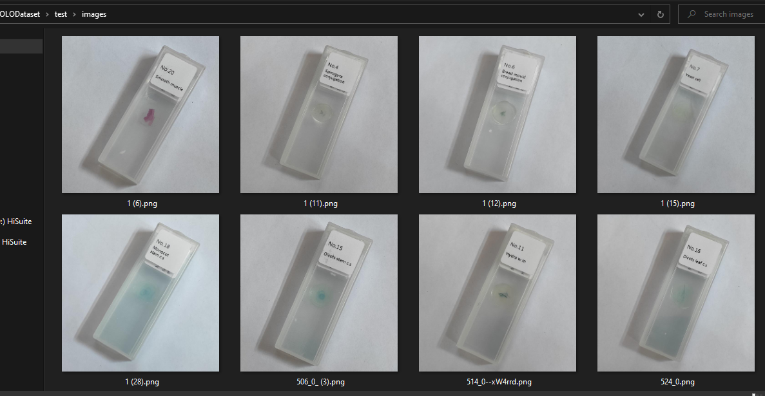

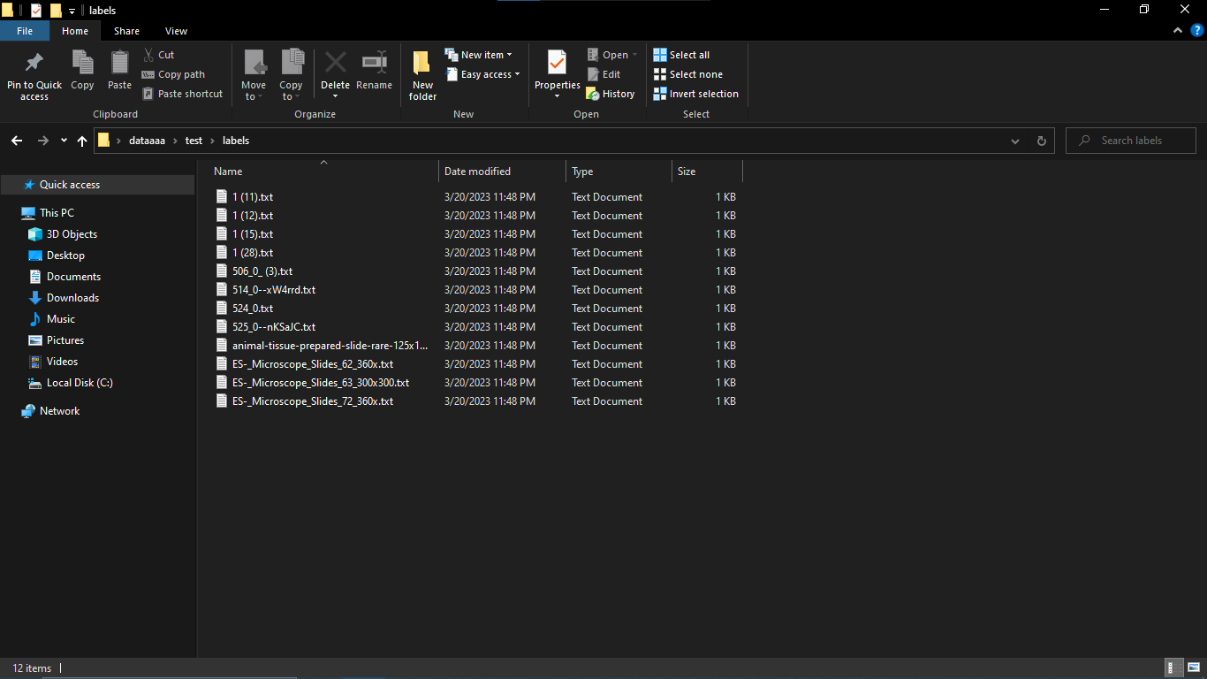

Part of the dataset (some slide images and their labels).

Given best.pt file

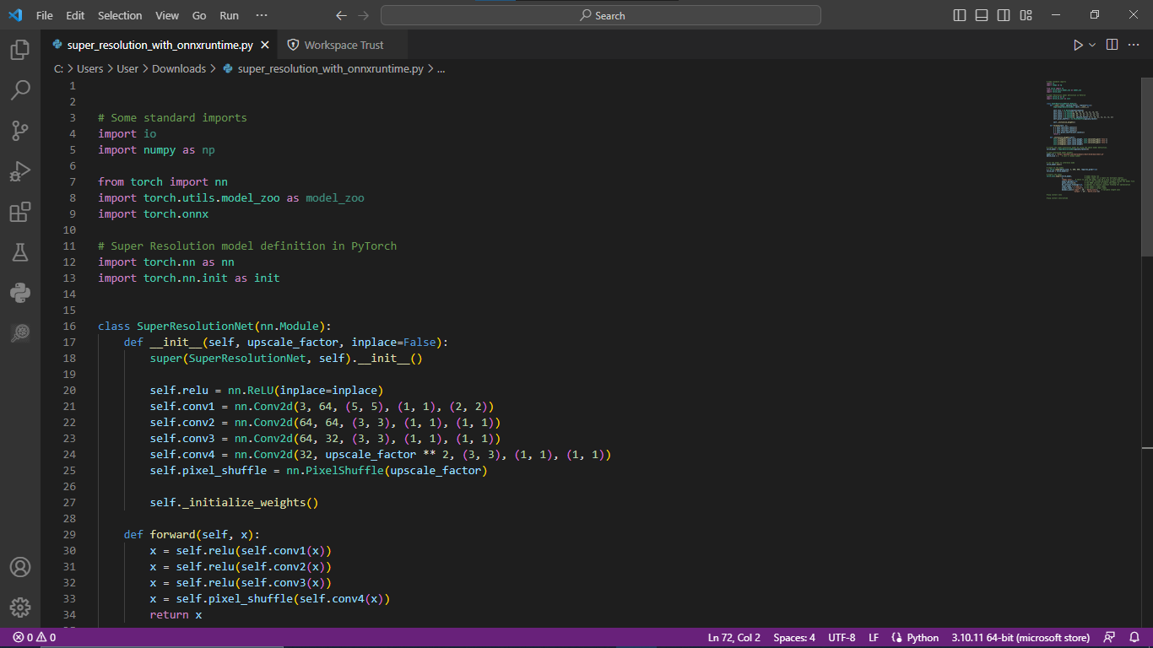convert best.pt to onnx file

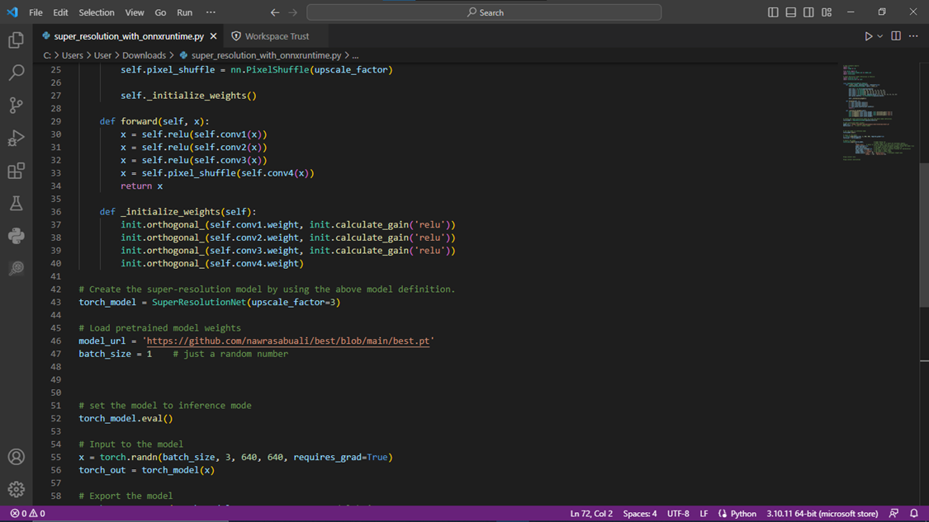

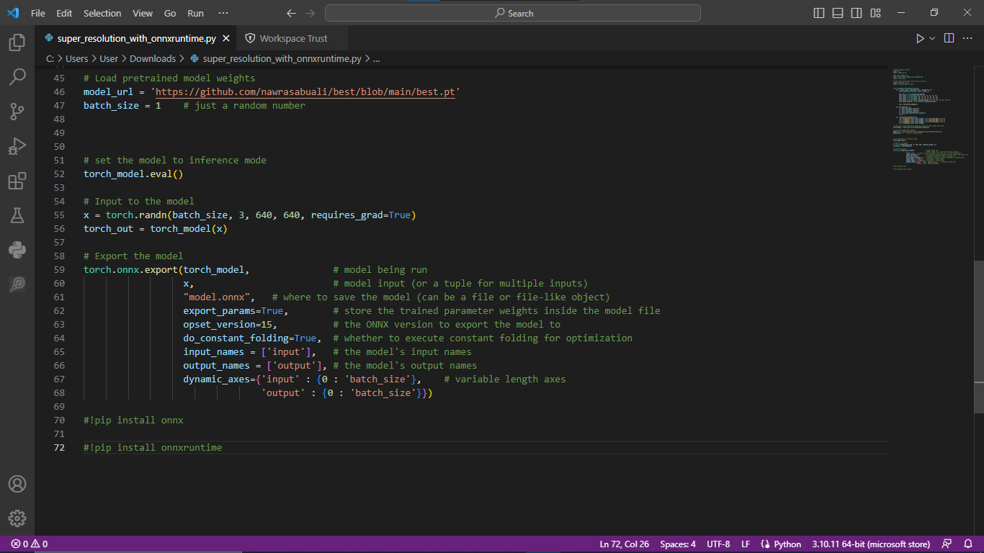

<https://www.youtube.com/watch?v=DMRlOWfRBKU&ab_channel=TheCodingBug>

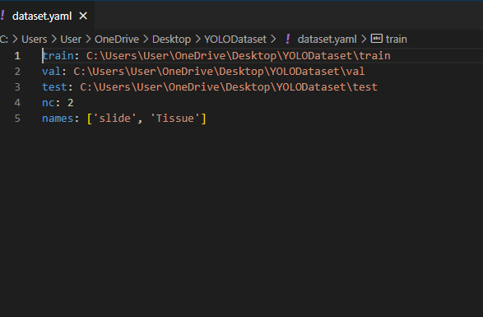

What is YOLO exactly?

YOLO (You Only Look Once) is a method / way to do object detection. It is the algorithm /strategy behind how the code is going to detect objects in the image.[5]

“**Deep learning**: is subset of machine learning that uses neural networks with multiple layers to analyze complex patterns and relationships in data. It is inspired by the structure and function of the human brain, and has been successful in a variety of tasks, such as image recognition, natural language processing, and speech recognition.

Deep learning models are trained using large amounts of data and algorithms that are able to learn and improve over time, becoming more accurate as they process more data. This makes them well-suited to complex, real-world problems and enables them to learn and adapt to new situations.”[2]

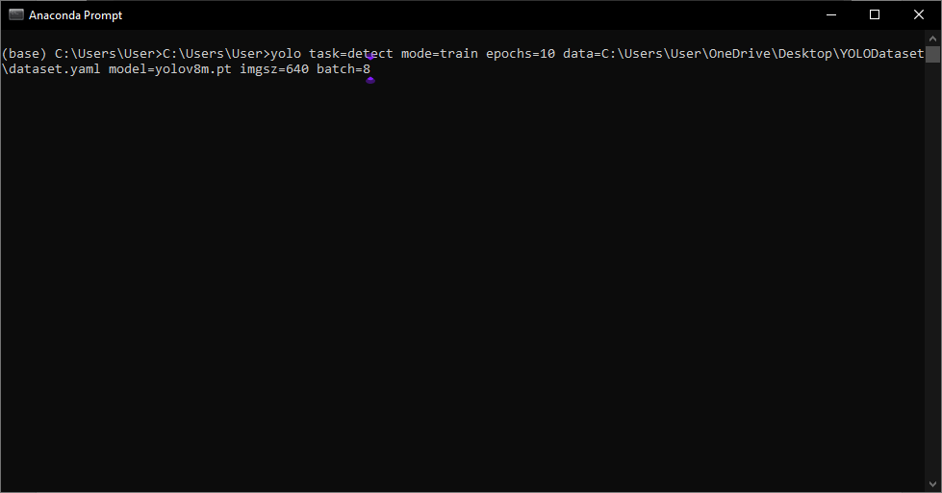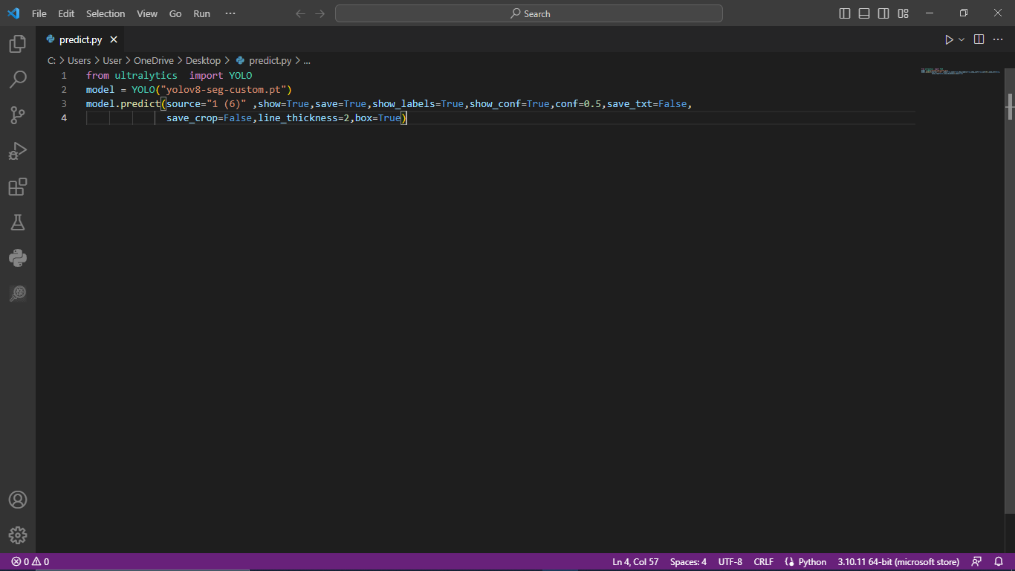

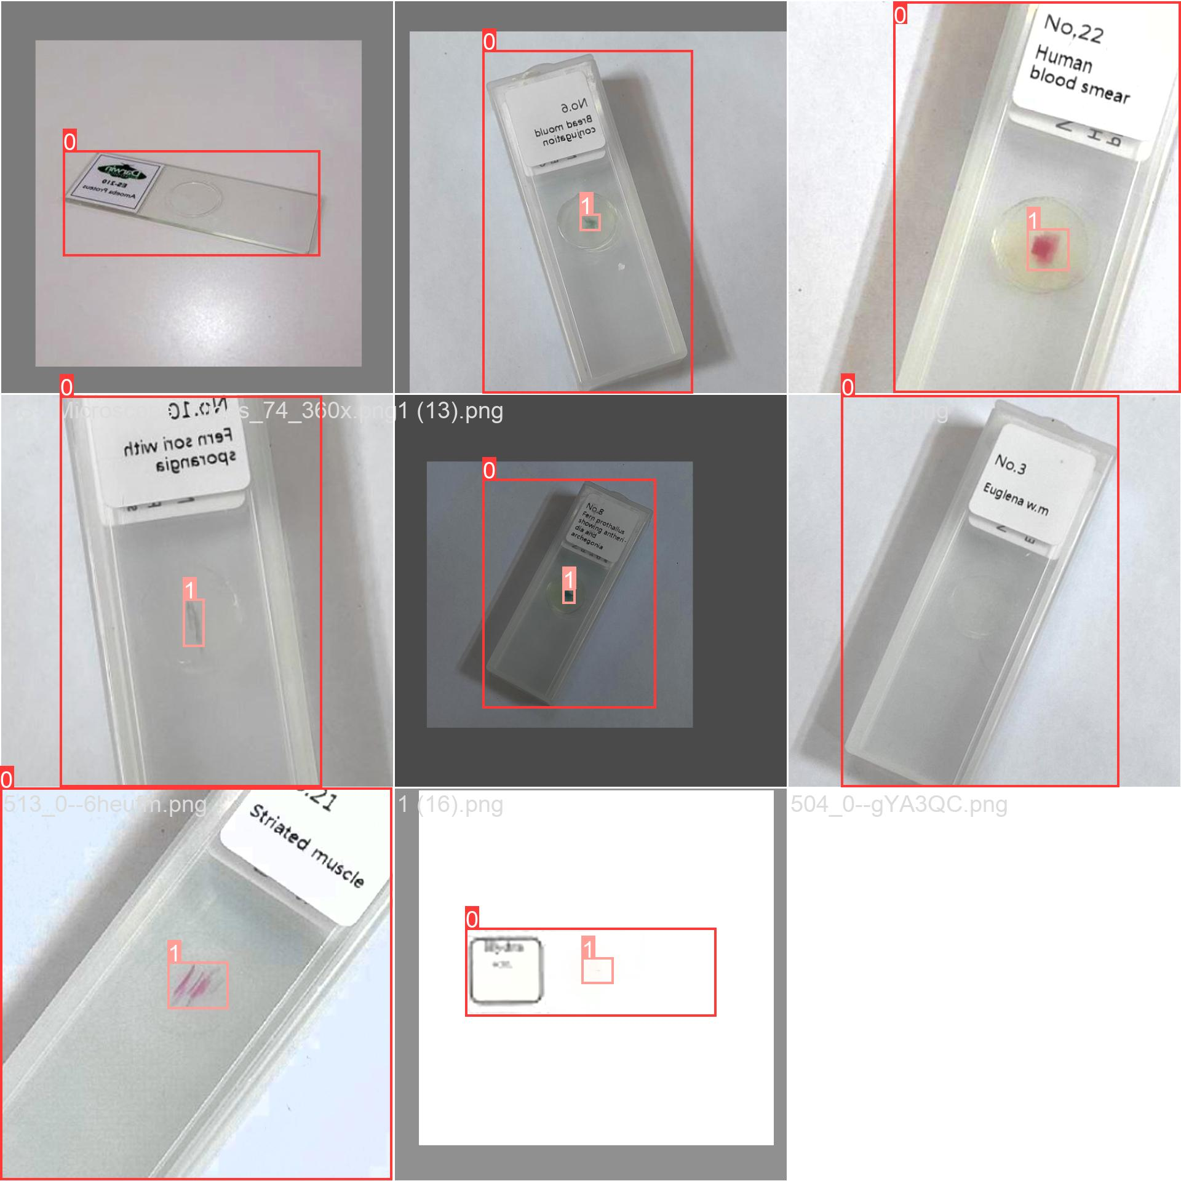

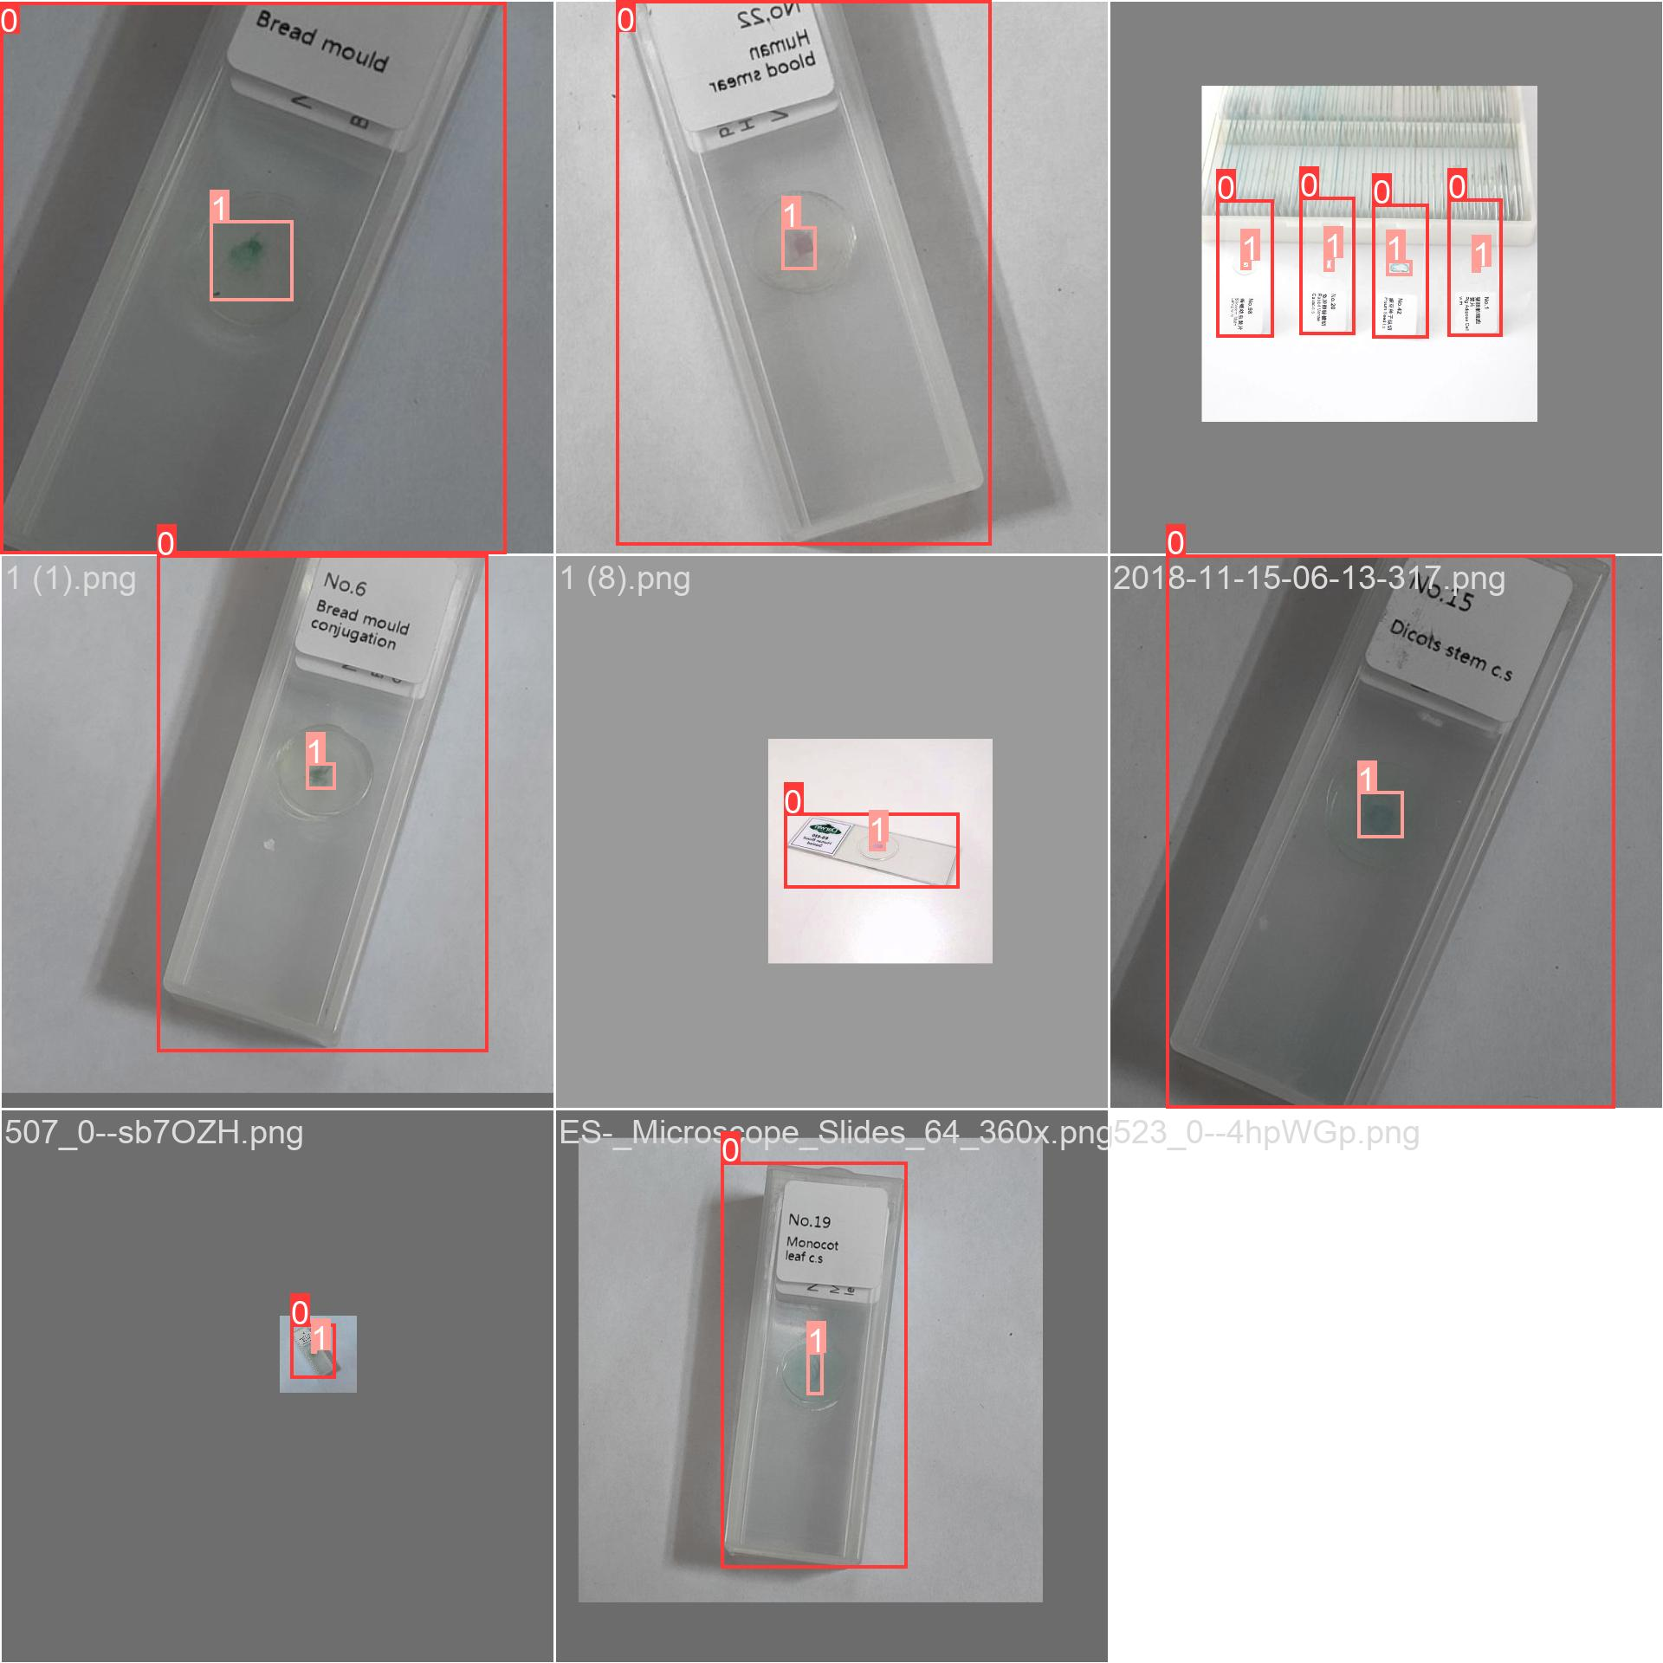

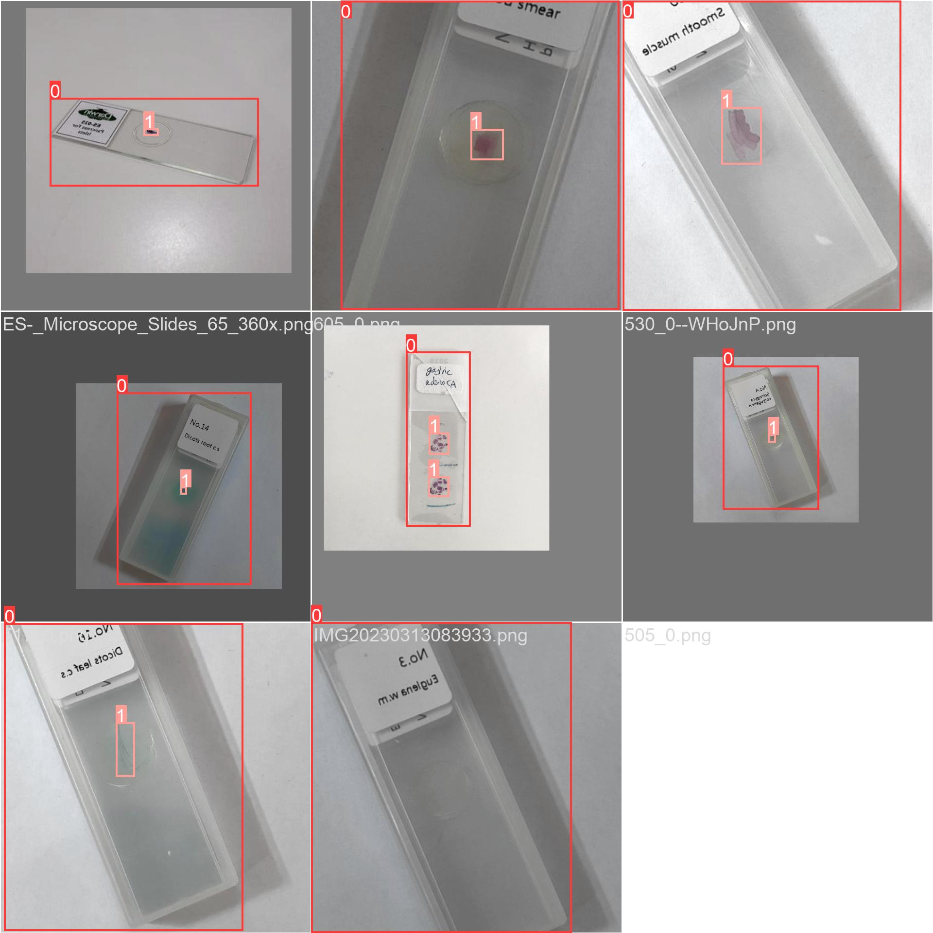

“The Open Neural Network Exchange (ONNX) is an open-source artificial intelligence ecosystem of technology companies and research organizations that establish open standards for representing machine learning algorithms and software tools to promote innovation and collaboration in the AI sector.”[3]

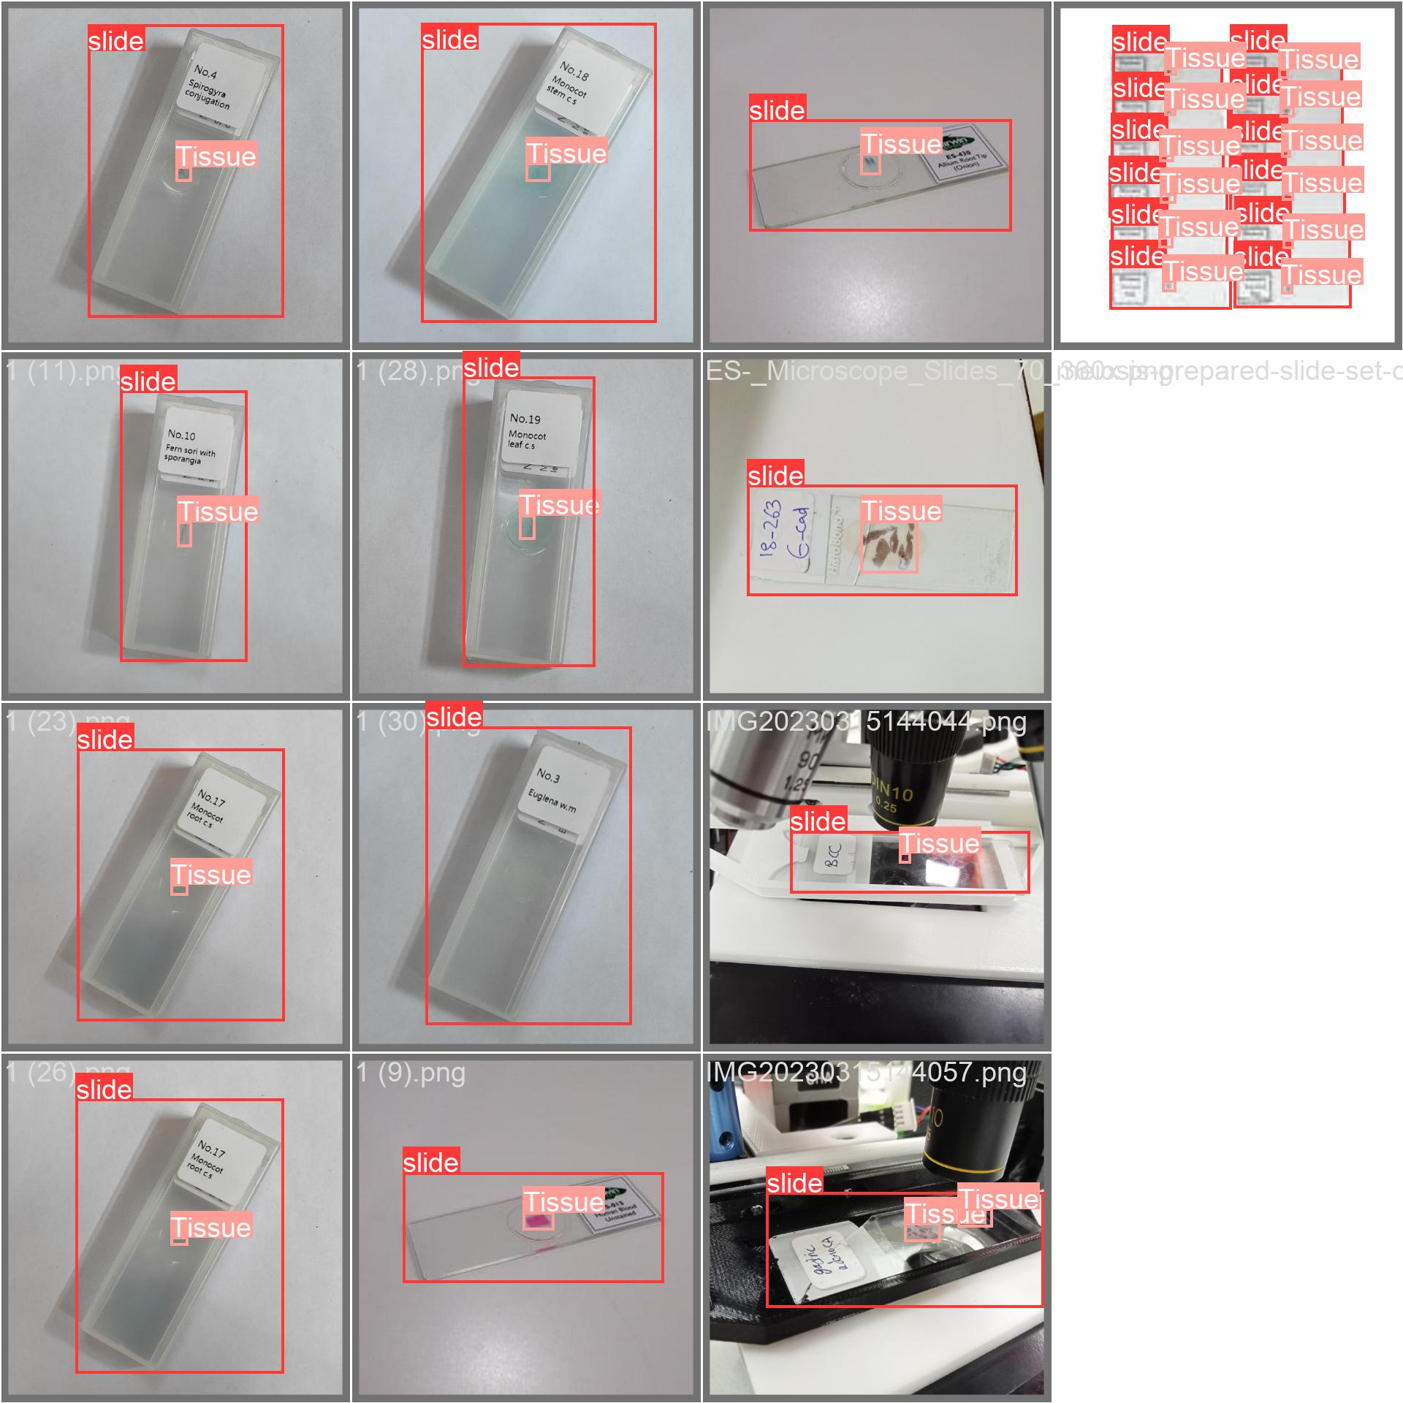

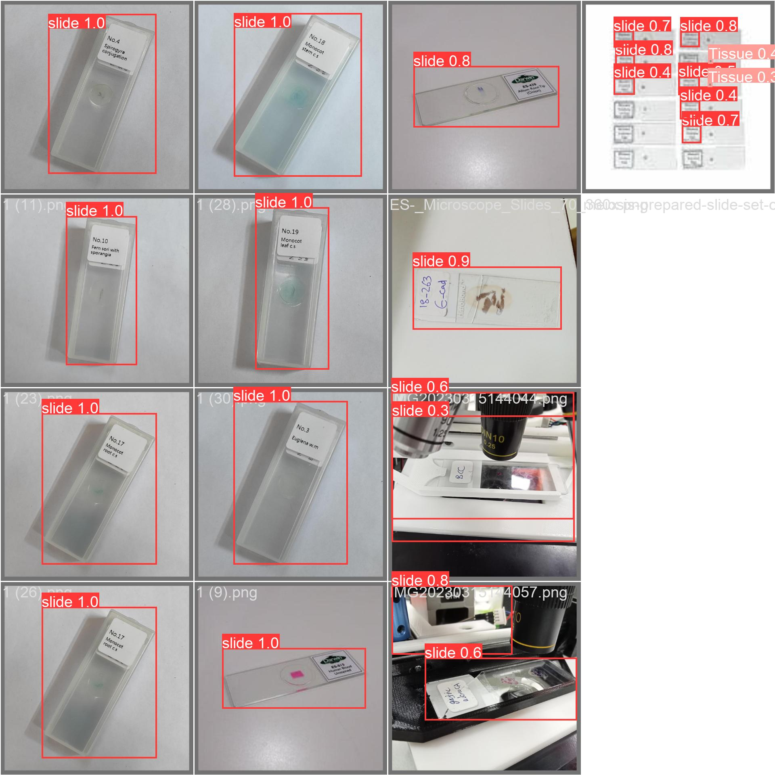

<https://learn.microsoft.com/en-us/azure/machine-learning/how-to-use-automl-onnx-model-dotnet>

<https://heartbeat.comet.ml/object-detection-in-android-ios-using-xamarin-forms-and-onnx-aa7d1d5bed3c>

<https://towardsdatascience.com/how-to-create-a-simple-object-detection-system-with-python-and-imageai-ee1bcaf6b111>

<https://towardsdatascience.com/trian-yolov8-instance-segmentation-on-your-data-6ffa04b2debd>

<https://www.tutorialspoint.com/how-to-detect-a-rectangle-and-square-in-an-image-using-opencv-python>

The **ultralytics** package provides an easy-to-use interface for running YOLO (You Only Look Once) object detection models. The **YOLO** class in the package allows you to load a pre-trained YOLO model and perform object detection on images or videos. The code you provided uses the **predict** method of the **YOLO** class to perform object detection on an input image. The **predict** method takes several arguments that control the behavior of the object detection and how the results are displayed and saved.

Here's a brief explanation of the arguments used in your code:

* **source**: The path to the input image file.
* **show**: If **True**, displays the input image with the detected objects highlighted. Default is **True**.
* **save**: If **True**, saves the output image with the detected objects highlighted. Default is **True**.
* **show_conf**: If **True**, shows the confidence score for each detected object. Default is **True**.
* **conf**: The minimum confidence score required for a detected object to be displayed or saved. Default is **0.25**.
* **show_labels**: If **True**, shows the label for each detected object. Default is **True**.
* **save_crop**: If **True**, saves a crop of each detected object. Default is **False**.
* **box**: If **True**, draws a bounding box around each detected object. Default is **True**

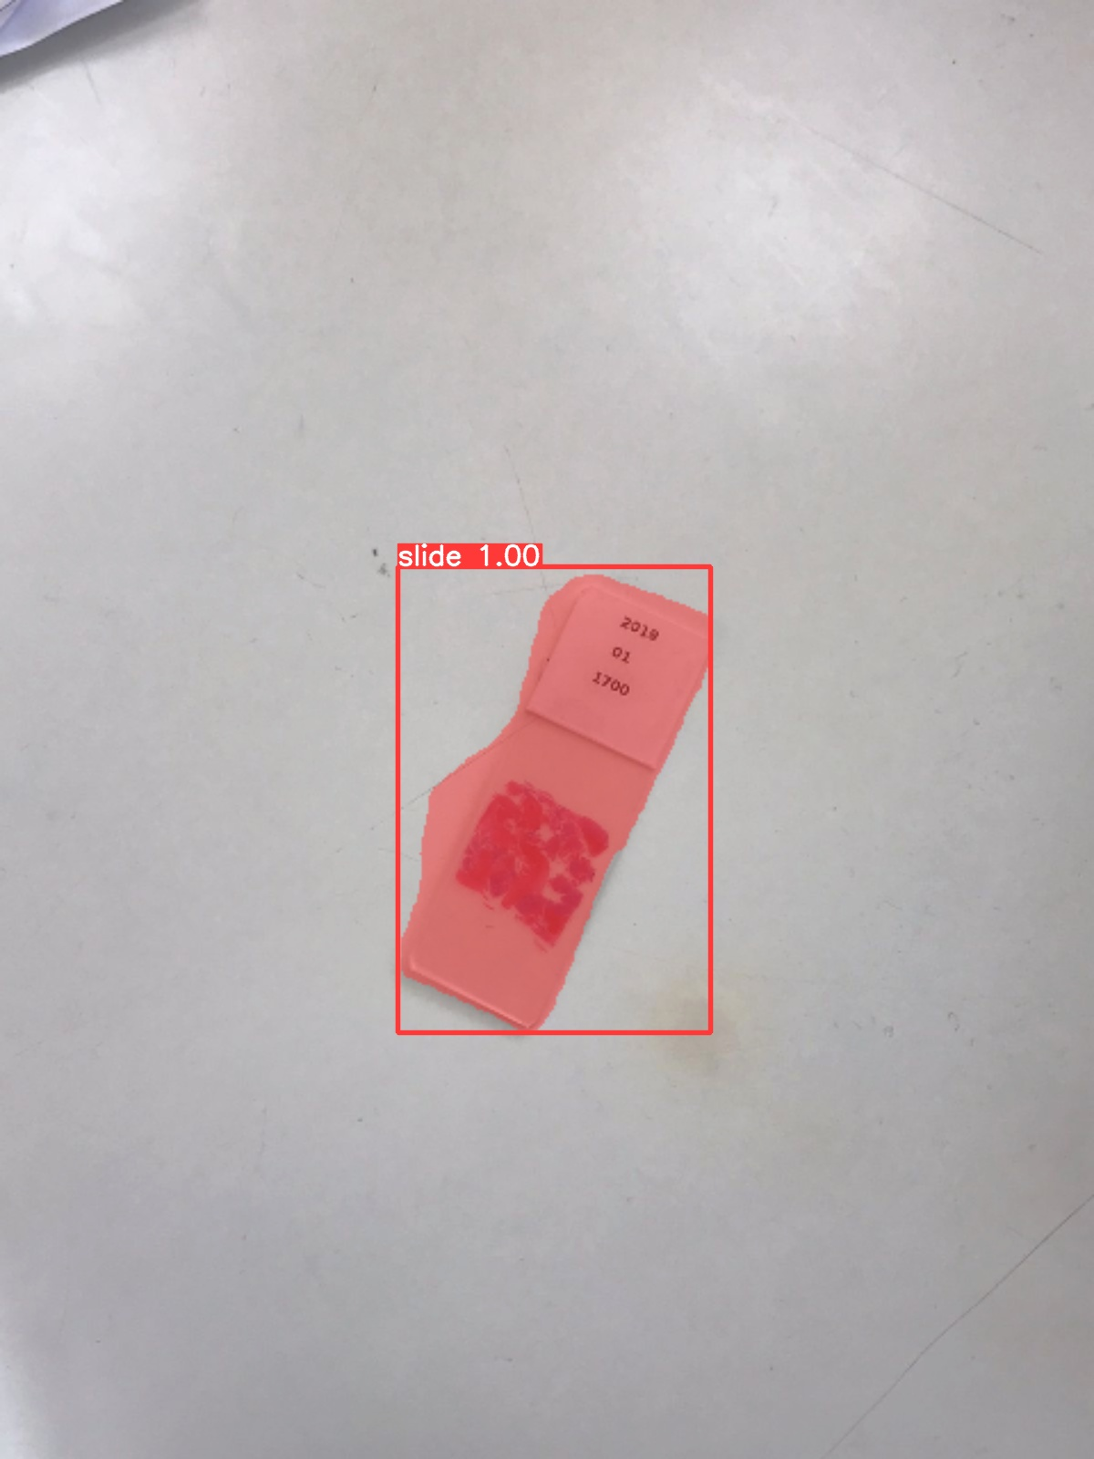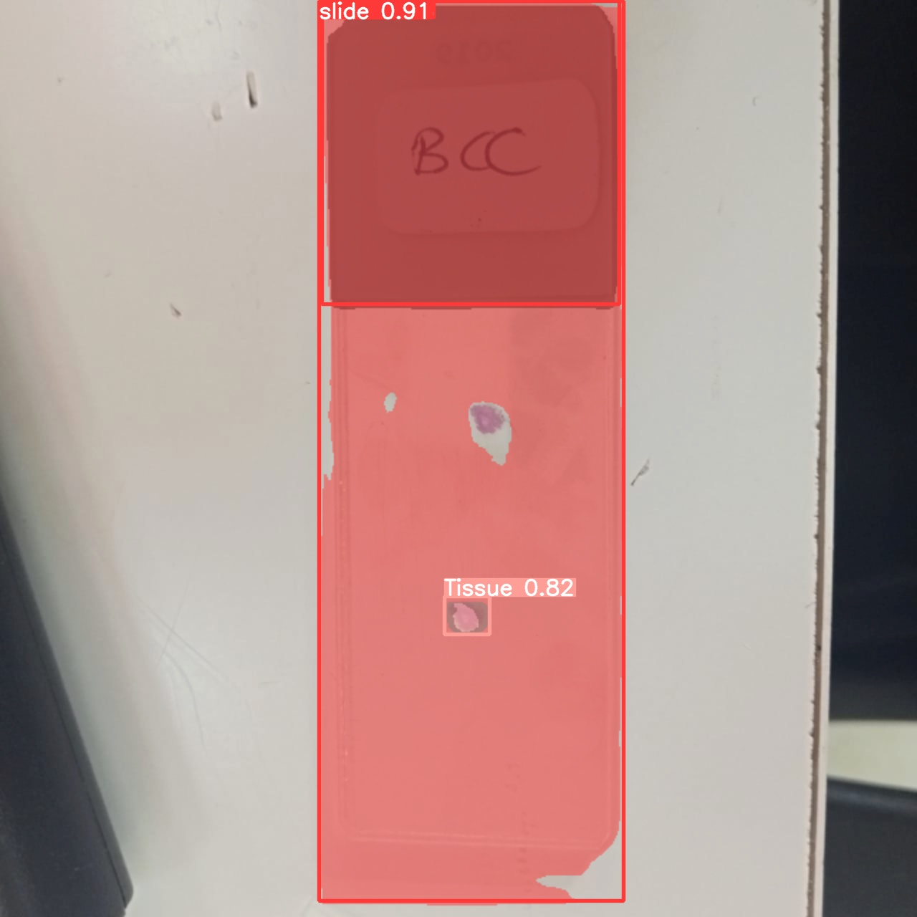

Object detection is a computer technology related to computer vision and image processing that deals with detecting instances of semantic objects of a certain class (such as humans, buildings, or cars) in digital images and videos. Well-researched domains of object detection include face detection and pedestrian detection. Object detection has applications in many areas of computer vision, including image retrieval and video surveillance.[4]

Methods for object detection generally fall into either neural network-based or non-neural approaches. For non-neural approaches, it becomes necessary to first define features using one of the methods below, then using a technique such as support vector machine (SVM) to do the classification. On the other hand, neural techniques are able to do end-to-end object detection without specifically defining features, and are typically based on convolutional neural networks (CNN).

**Non-neural approaches:**

Viola–Jones object detection framework based on Haar features

Scale-invariant feature transform (SIFT)

Histogram of oriented gradients (HOG) features

**Neural network approaches:**

Region Proposals (R-CNN, Fast R-CNN, Faster R-CNN, cascade R-CNN.)

Single Shot MultiBox Detector (SSD)

You Only Look Once (YOLO)

Single-Shot Refinement Neural Network for Object Detection (RefineDet)

Retina-Net

Deformable convolutional networks

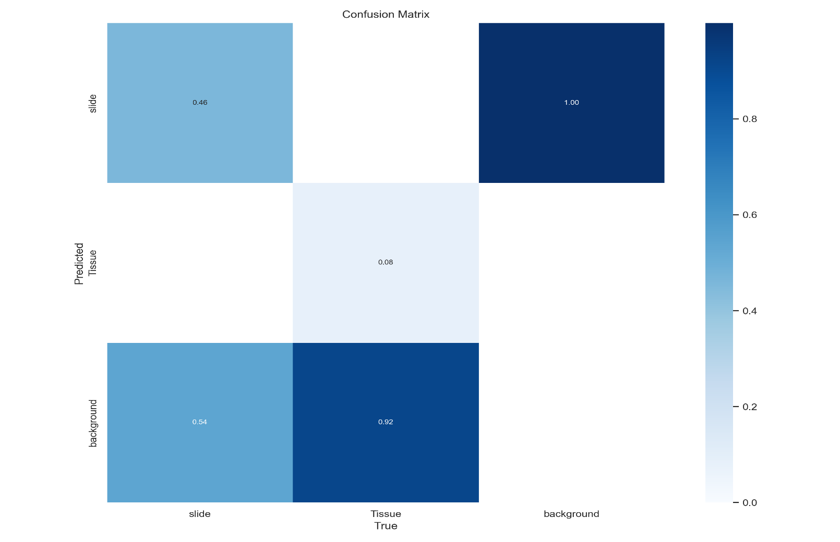

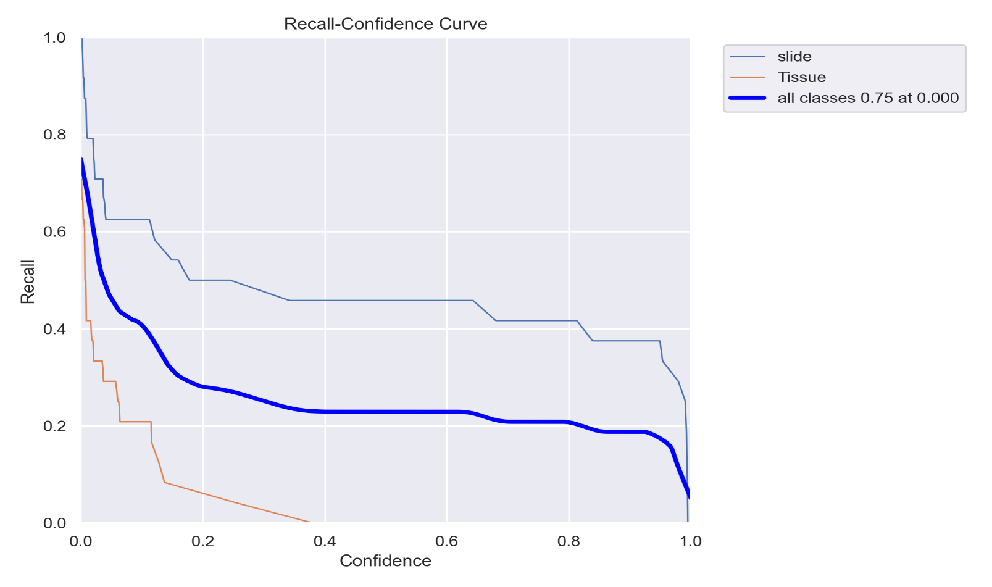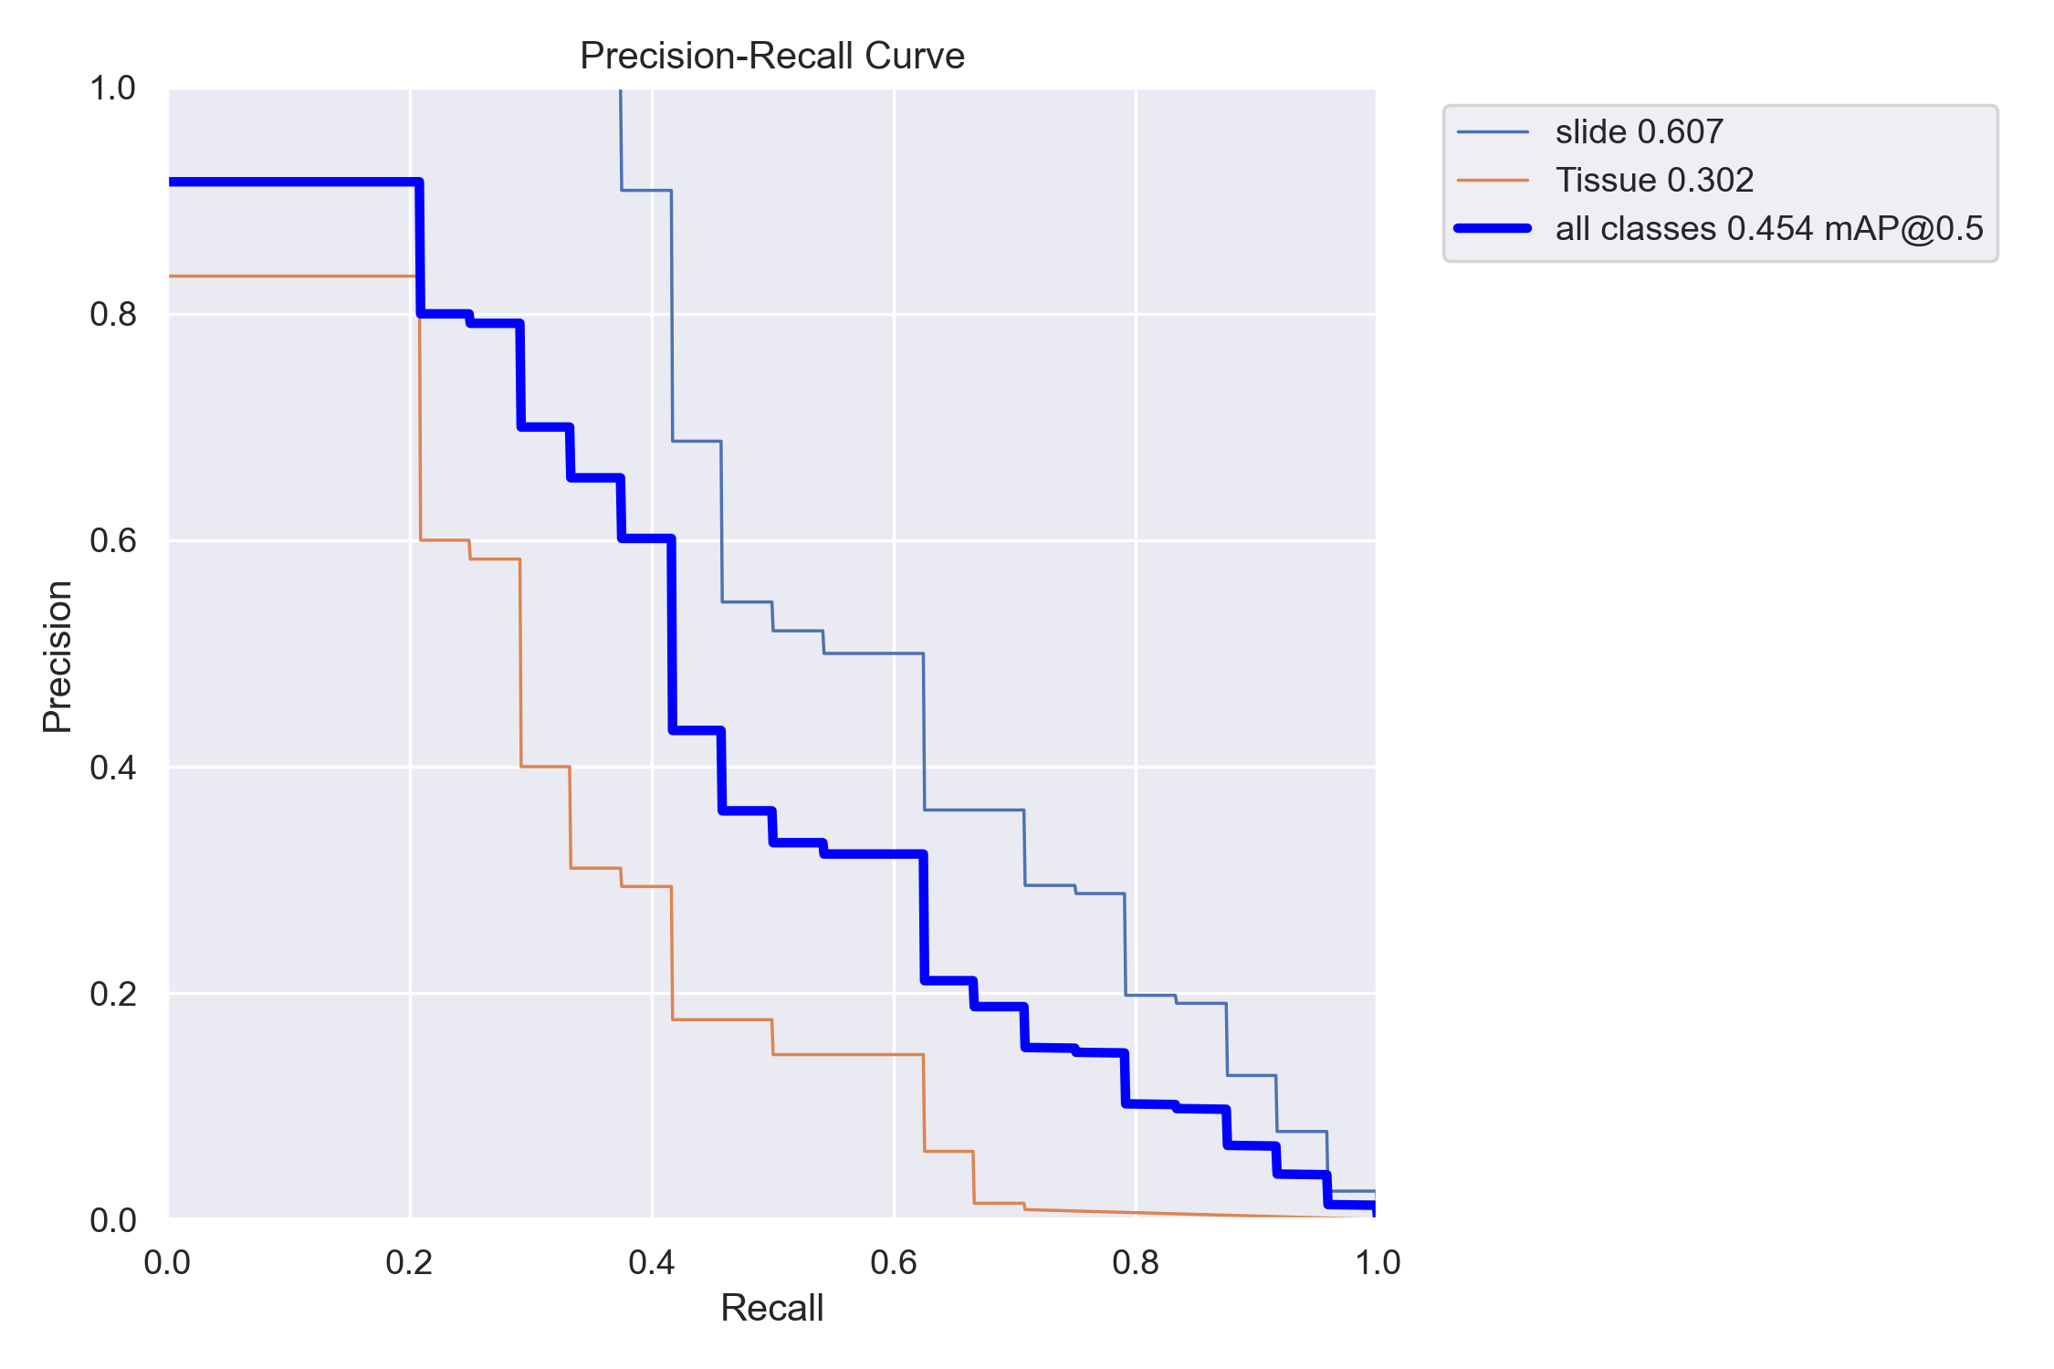

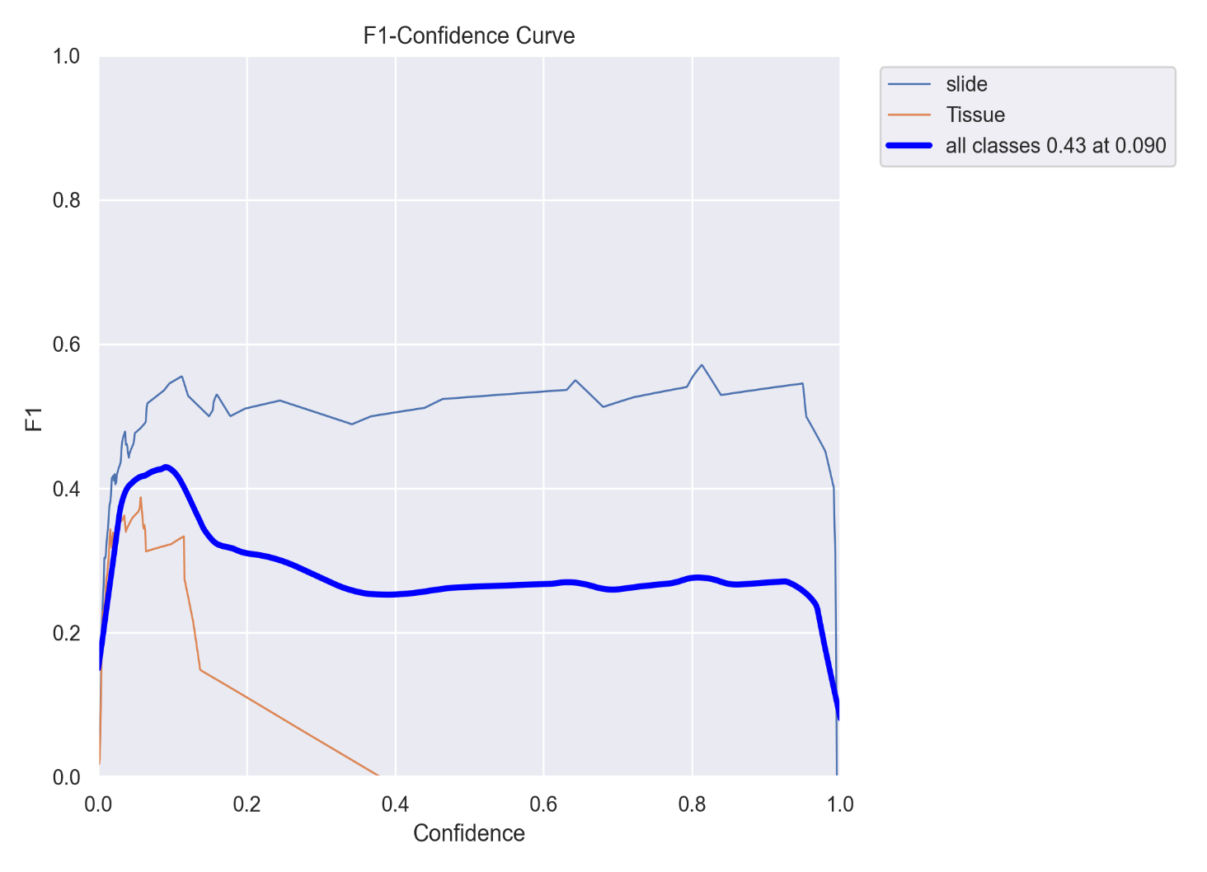

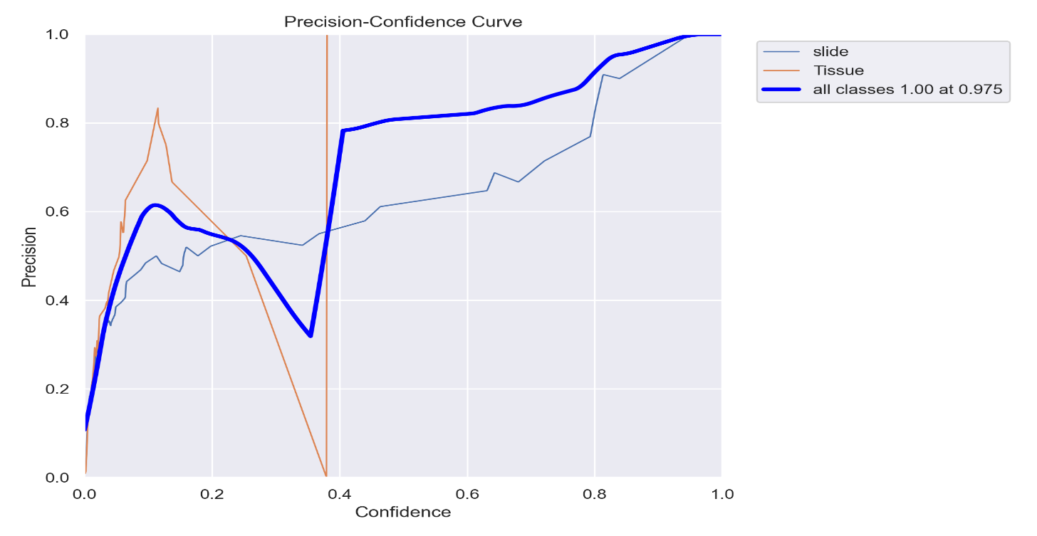

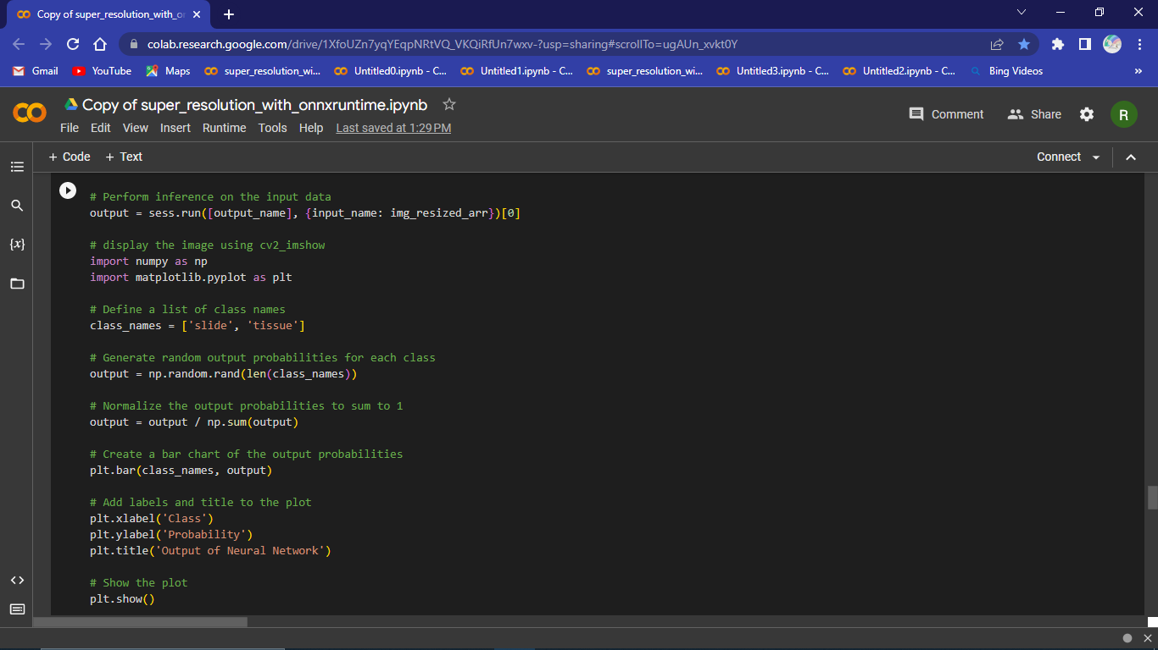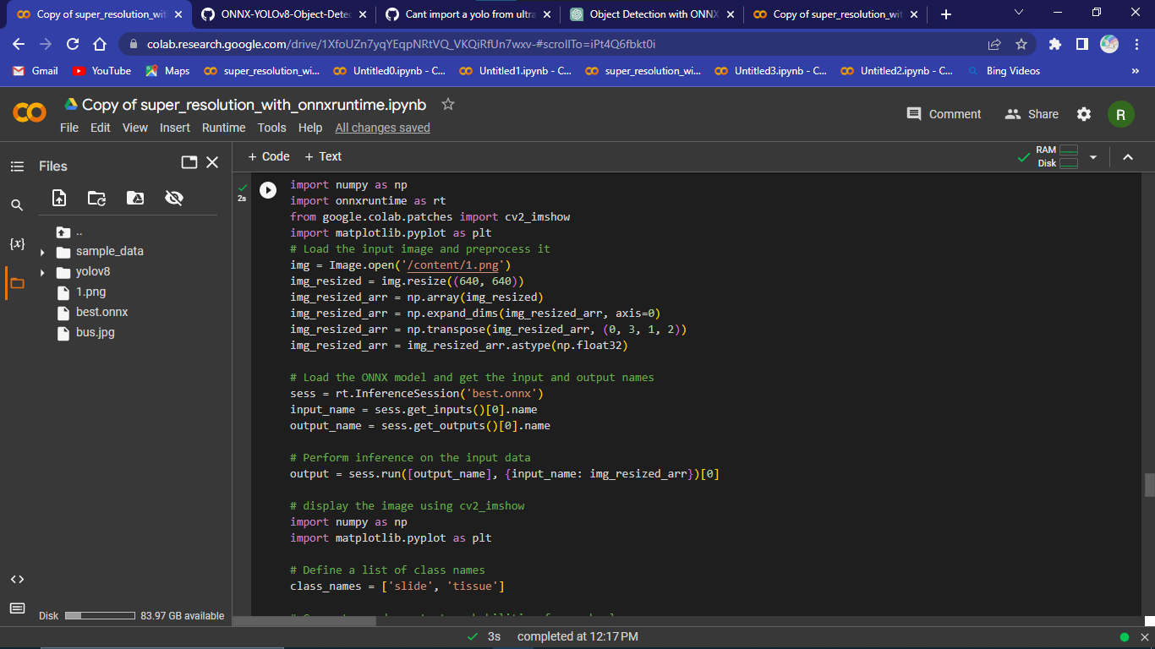

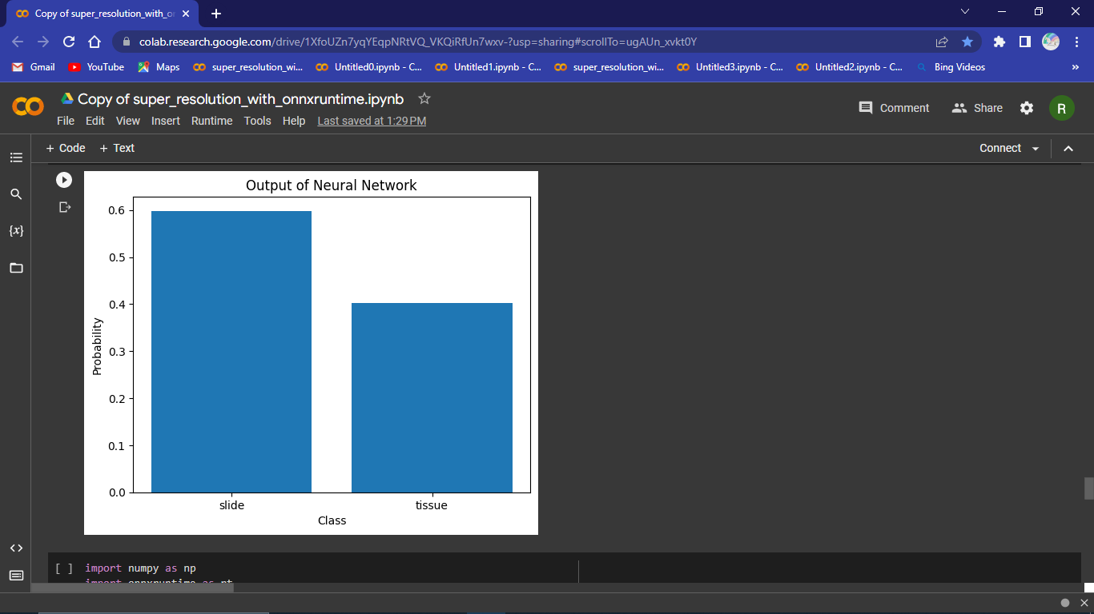

To build mobile application that captures multiple image and merge them in one image

Using mvvm/xamarin forms🡪Flyout.

I was asked to make it step by step, the first step just to learn the concept of combining image.

First, I wrote this code that merges 2 images.

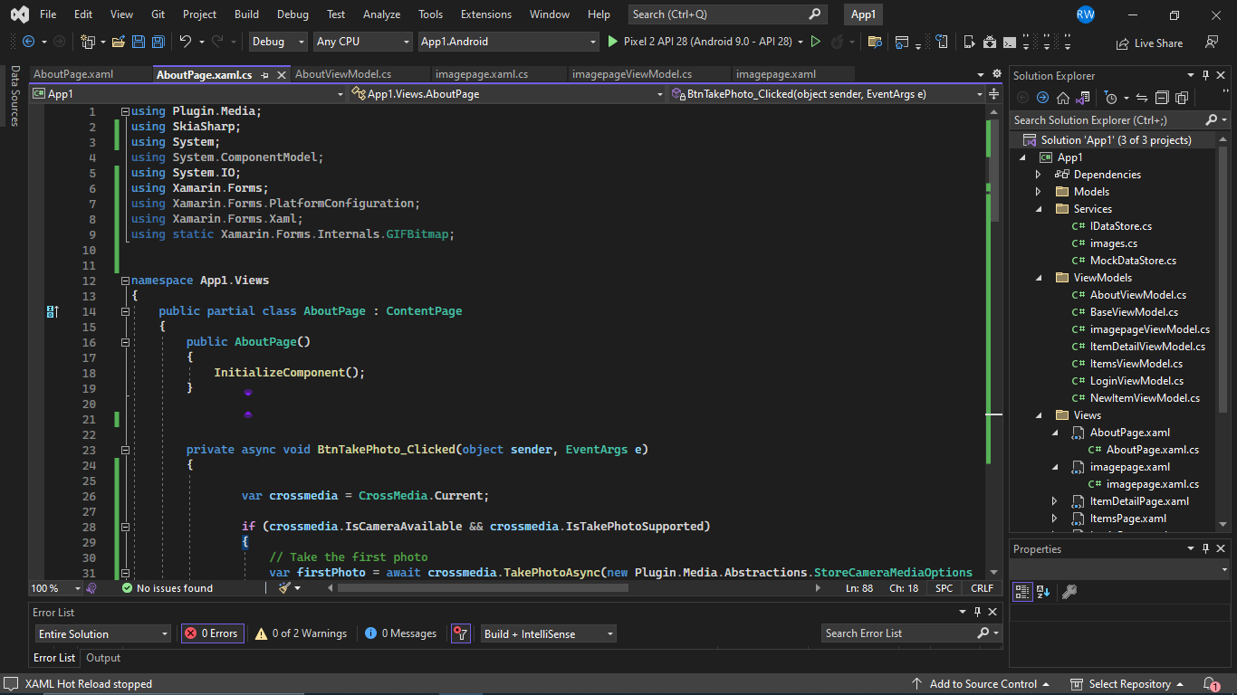

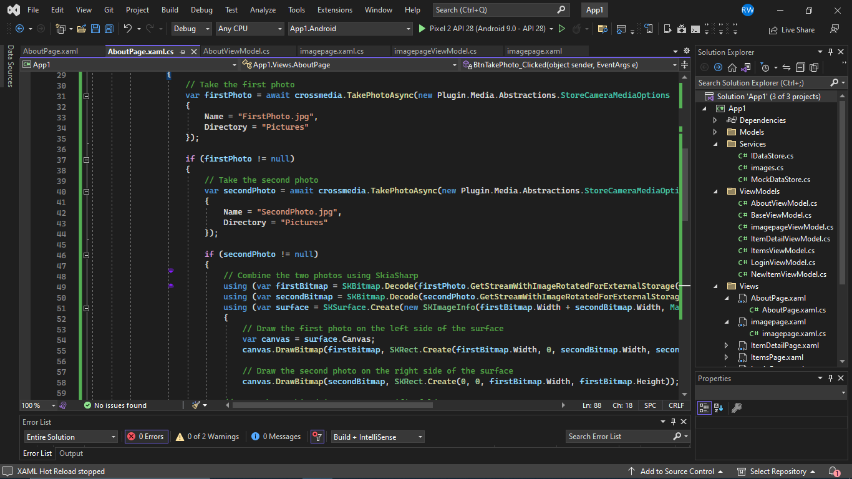

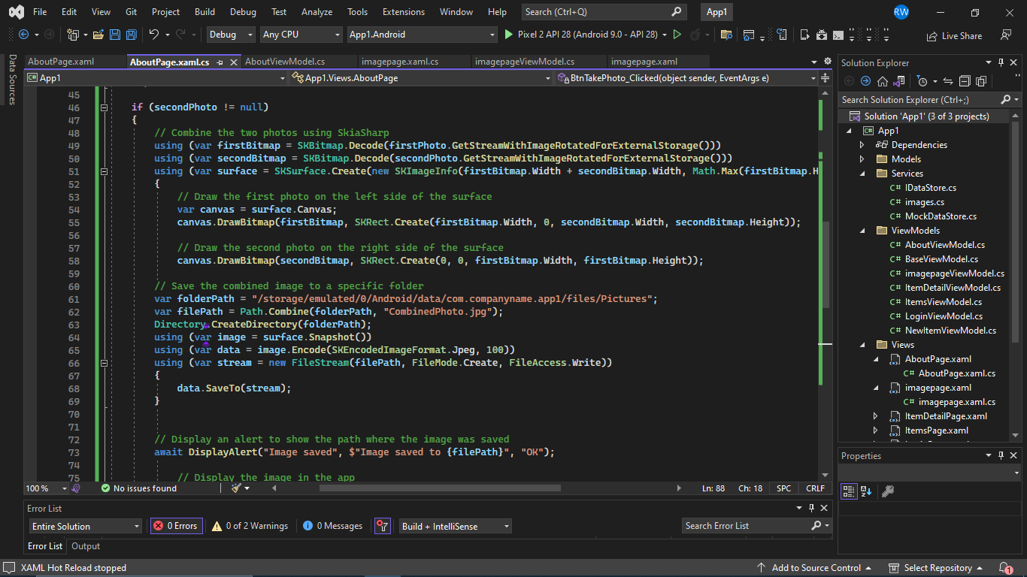

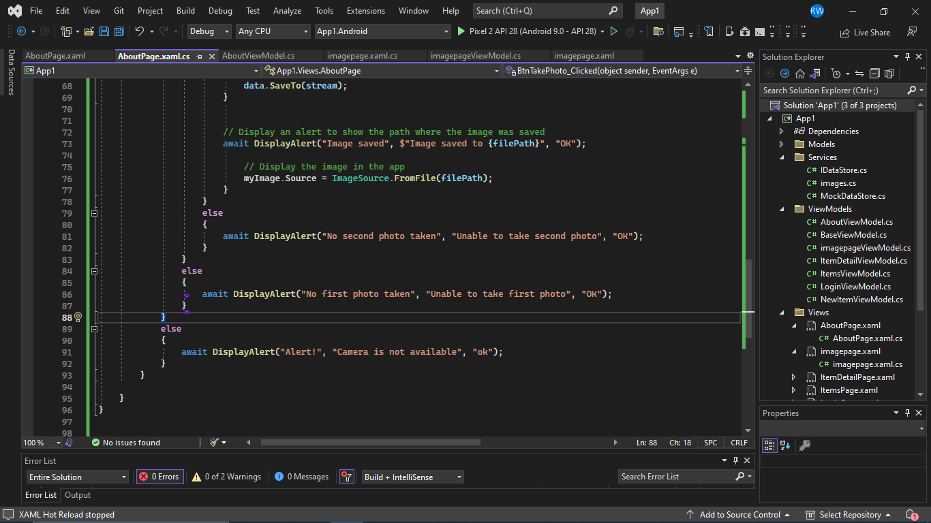

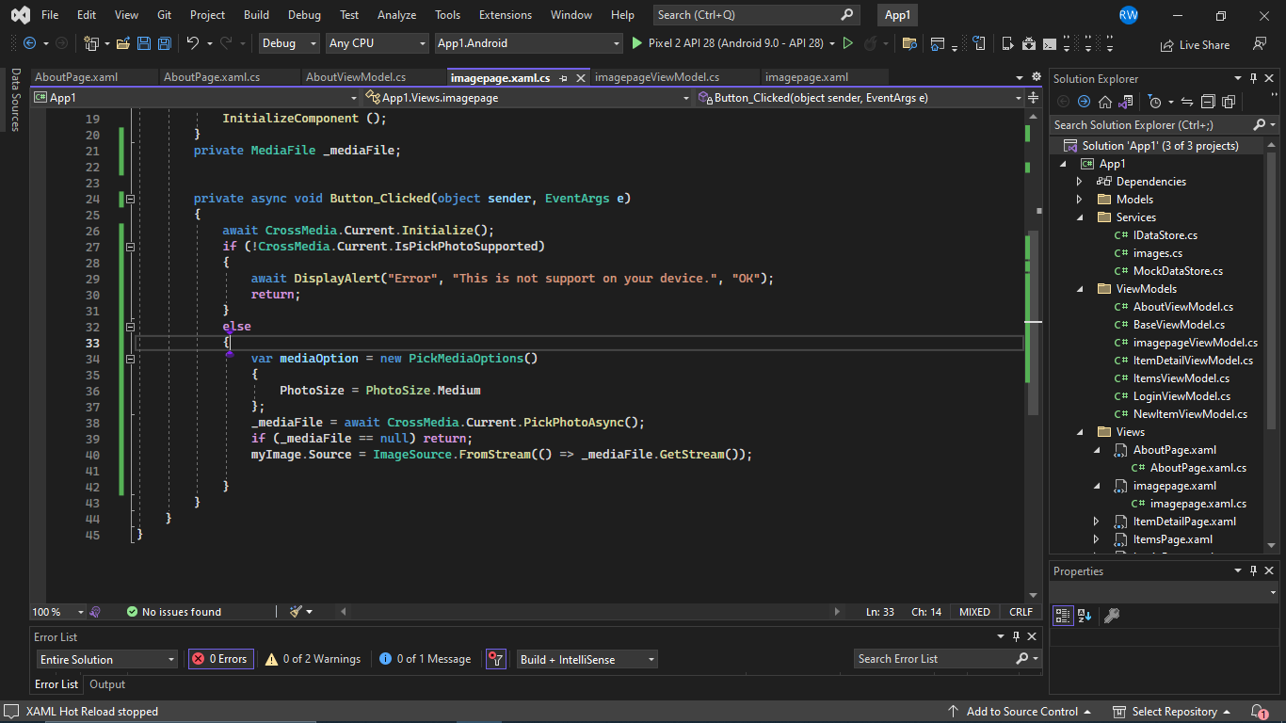

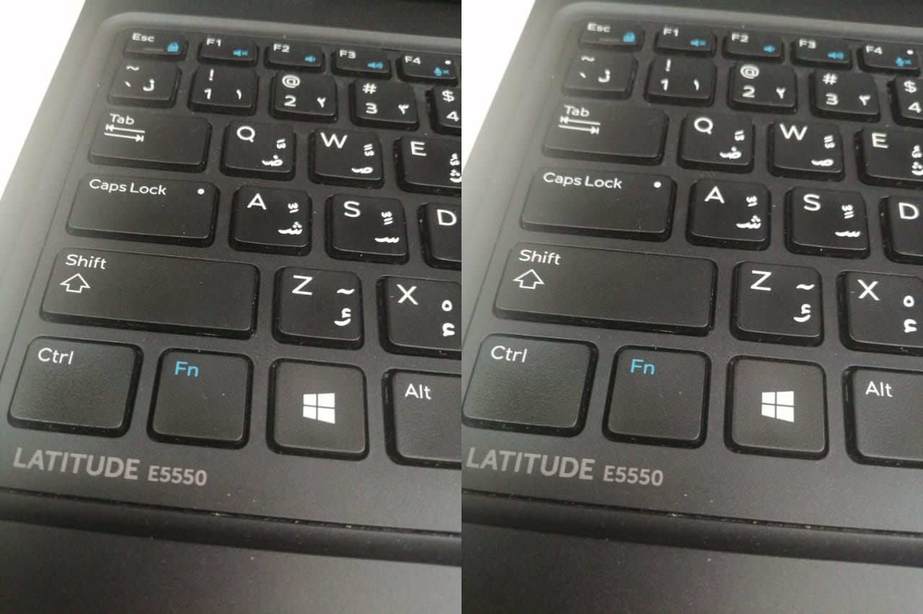

Second step :make changes on the code to increase the number of images🡪 merges 15 images, the user is required to click on the capture image each time and this is not practical so the next step I want to make some changes on the code to make it capture more than one image in a single click.

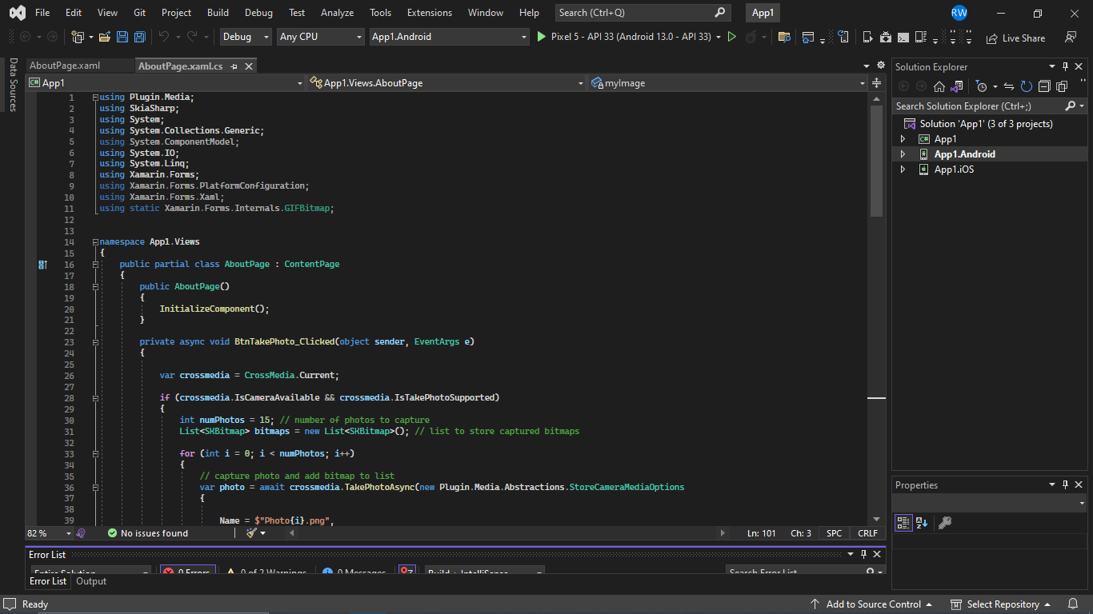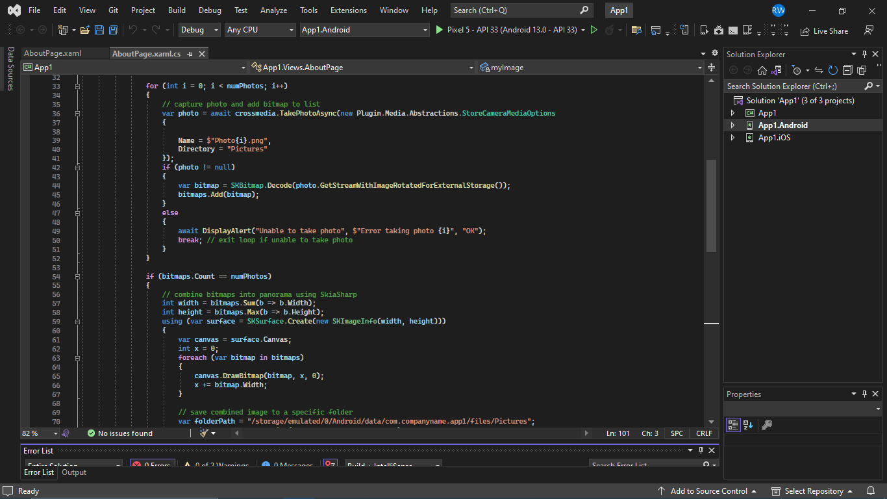

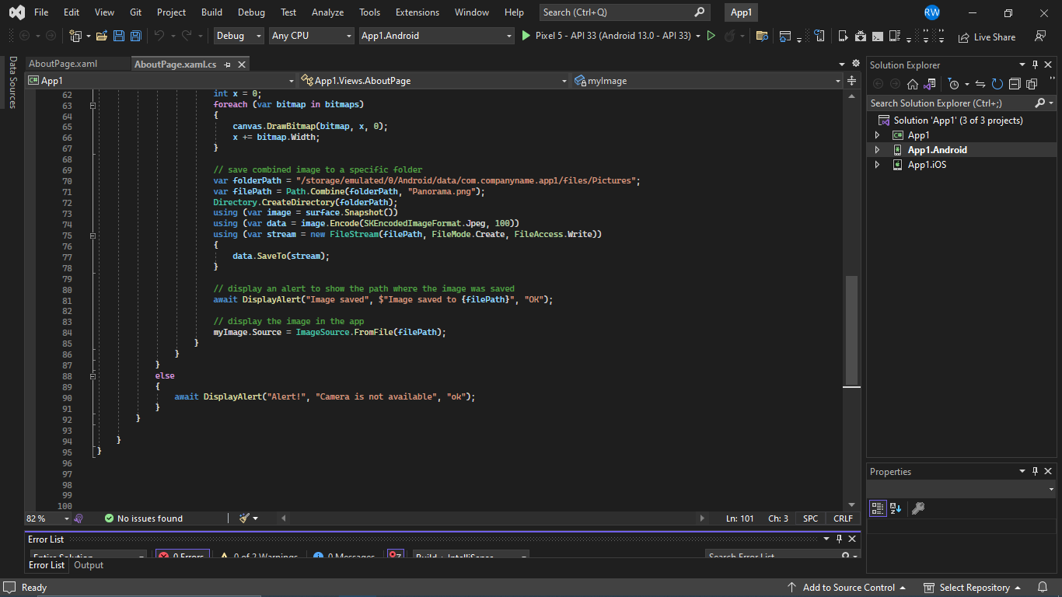

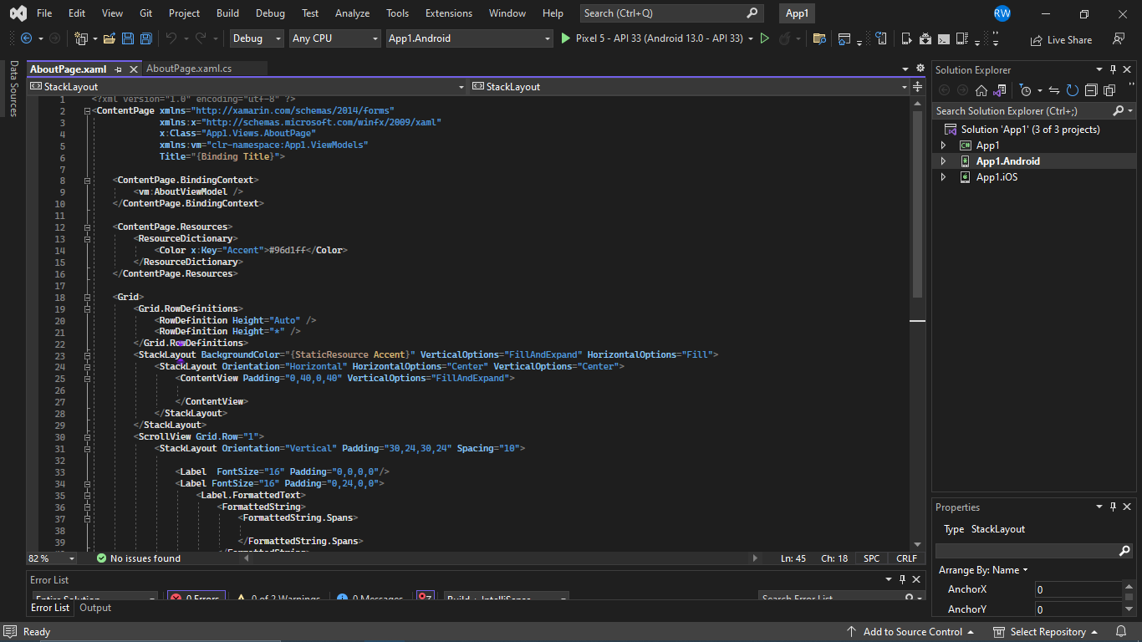

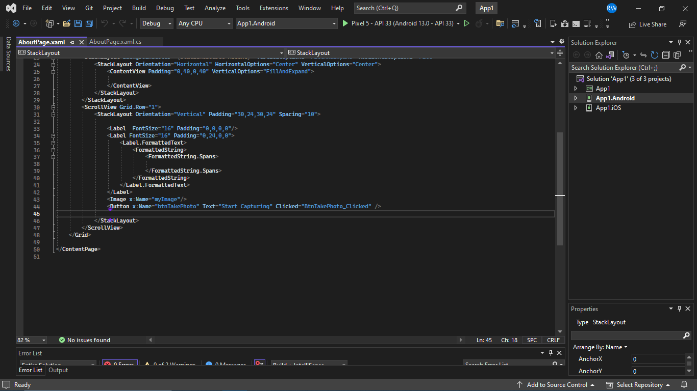



[1]<https://learn.microsoft.com/en-us/xamarin/get-started/what-is-xamarin>

[2] <https://www.geeksforgeeks.org/difference-between-machine-learning-and-deep-learning/>

[3] <https://en.wikipedia.org/wiki/Open_Neural_Network_Exchange>

[4] <https://en.wikipedia.org/wiki/Object_detection>

[5] <https://towardsdatascience.com/yolo-object-detection-with-opencv-and-python-21e50ac599e9>